AMMA-2050 Climate Metrics Atlas v0.2.1

# General Comments

**Dave**

* Can we have the text ASAP please, for Chris and I to look over before release of 0.2.2
* We need to be clear now on the content of v0.2.2. It should be one full and complete sub-atlas (single pdf file). If v1 is one 'sub-atlas' per region and dataset type, how many figs/pages is that? Or do we need to have separate files for each month/season as well to prevent them being too large?
* (Sub-)section headings need to be much clearer (bigger, bold, maybe separate page) cos they're v useful!
* What other plot types did we agree?
* Increase font size of axis labels
* Need to include clear definitions of the metrics, checked with Chris & Dave

# About this version

This is a preliminary release for Dave and Chris to review plots, and suggest improvements and additions. It is intended to provide a first look at the revised plots, and identify actions to complete before v0.2.2 is released in late September 2017. Please add to the lists of ‘TODO’ items below each plot. The following variables have been sub-selected for the purposes of this review:

* Region: Burkina Faso
* Scenario: rcp8.5
* Bias correction method: BC_0.5x0.5 (bias corrected and disaggregated to 0.5˚)
* Season: JAS (with the exception of the onset index)
* Metrics:
  + Number of hot days (tasmax > 40˚C)
  + Maximum seasonal precipitation
  + Monsoon onset data (Marteau method)

The following list describes briefly all the plots (and various sub-types) that we have currently produced.

* Plots for each variable (sub-divided by the data shown):
  + Boxplots of:
    - absolute anomaly by scenario
    - % anomaly by scenario
    - historical vs scenarios
  + Histograms of:
    - absolute anomaly (one scenario)
    - % anomaly by scenario
    - historical vs scenarios side-by-side
  + Model ranking scatterplots of:
    - Each scenario (and historical) individually
    - Absolute anomaly (one scenario)
    - % anomaly (one scenario)
  + Spaghetti timeseries of:
    - All scenarios for 1950-2100
  + Maps of ensemble spread (10th and 90th percentiles):
    - Each scenario (and historical) individually
    - Absolute anomaly (one scenario)
    - % anomaly (one scenario)
  + ‘Number of model’ histograms of:
    - Absolute anomaly (one scenario)
    - % anomaly (one scenario)

In the latest version of the code, the old GUI has been greatly simplified, and all the code written by African partners has been retained. Additionally, the plotting code written by African partners during the Leeds workshop was used as a starting point for v0.1 of the atlas, and has subsequently been refined for the version (v0.2.1). To give an idea of the scale of the task, the following table summarises the python files, number of functions and lines of code involved.

|  |  |  |
| --- | --- | --- |
| **Script name** | **No. of functions** | **No. of lines** |
| calc.py | 18 | 585 |
| constants.py | 0 | 32 |
| labeller.py | 3 | 86 |
| master.py | 4 | 175 |
| mplot.py | 10 | 722 |
| utils.py | 10 | 230 |
| writeNetcdf.py | 4 | 134 |
| **Total** | **49** | **1964** |

# Number of hot days (tasmax > 40˚C)

## Boxplots

### Absolute anomaly by scenario

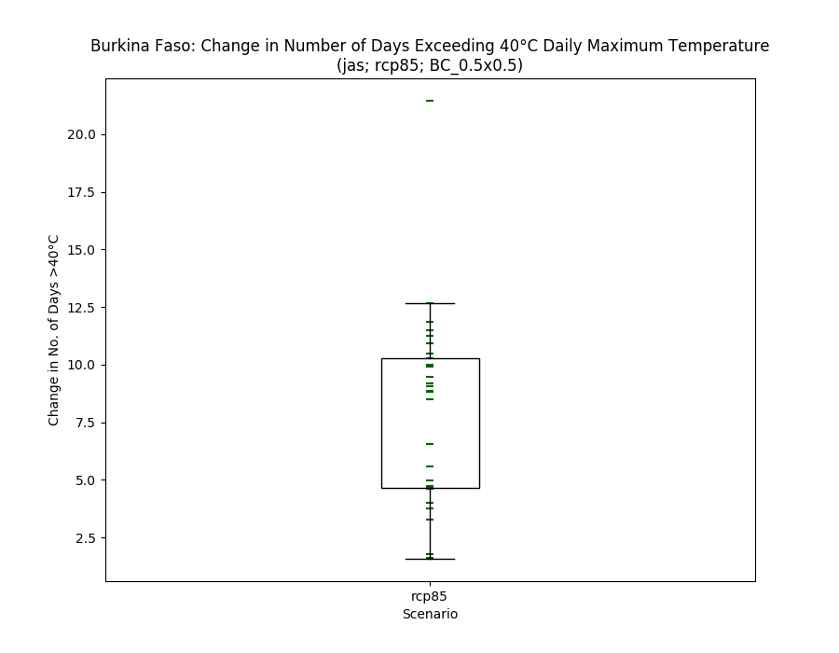

* Currently only shows 1 scenario, but will show more when they are processed
* Median line removed intentionally, box shows inter-quartile range
* Dave: I missed the outlier until I saw it in a later fig. Need to either mark full range with the longer horiz line or extend the vertical line over all models (all box-and whiskers plots). And if the longer horiz line is kept, say what it is (do we need formal fig captions, or are you trying to avoid these?).
  + Andy: We do need formal figure captions – I did these automatically for the previous version, but I left them out here in favour of getting all the plots done. Requires a bit of tweaking, but not too much
  + Andy: the point about extending the vertical line goes against the common boxplot convention (the line always goes up to 10th and 90th percentile), which also fits nice with the map plots. We can make the line extend to the max min points though.

### % anomaly by scenario

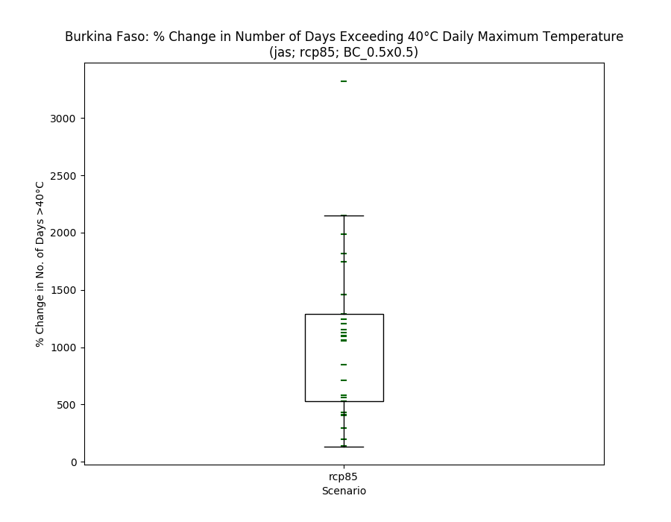

* Perhaps this is not appropriate to show % change in the number of days?
* Dave: Agree don't show % change nDayT>40 (all plot types). But maybe actual changes in this metric does need some context of hist values (though in general I'm against this cos model hist could be more confusing than useful), in which case putting hist and fut together on one box-and-whiskers plot is clearer.
  + Andy: So conclusion is to remove this plot, and only have the next boxplot

### Historical vs scenarios

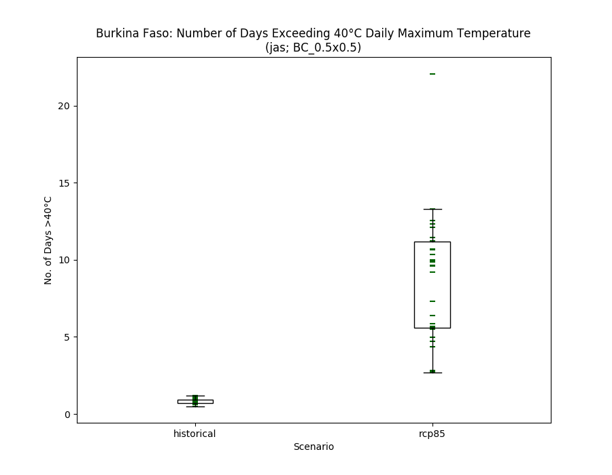

* Andy: Keep this one

## Histograms

### Absolute anomaly (one scenario)

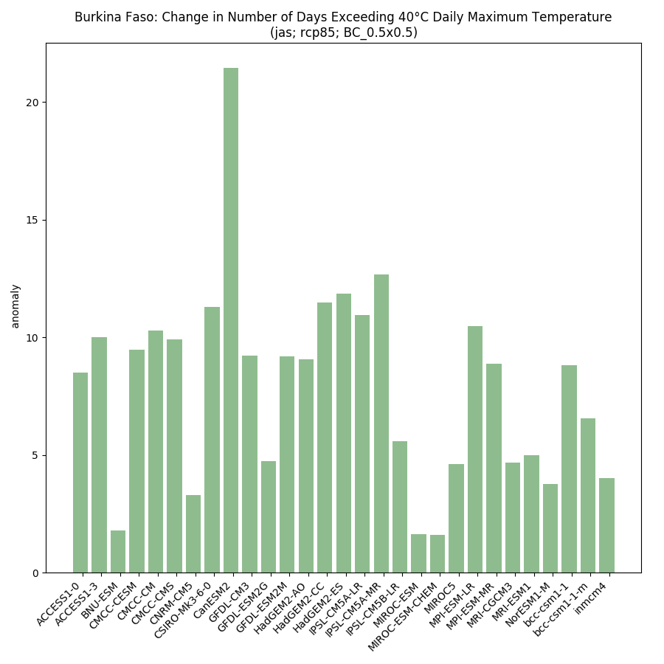

* Y-axis needs to be changed to ‘Number of days’
* The value is actually the number of days per year that the threshold was exceeded, averaged over the climatological period (1950-2000 for hist; 2040-2069 fut)
* Colours OK?
* Dave: I'd suggest removing the histograms with results for individual models, as they contain the same info as the box-and whiskers plots but will triple the no. of figs when all scenarios are included. Or have I said before they should be included and forgotten?! That said, they do add info associating values with named models. How useful is this for the audience? I'm inclined to think conciseness is more important to most of our audience.

### % anomaly by scenario

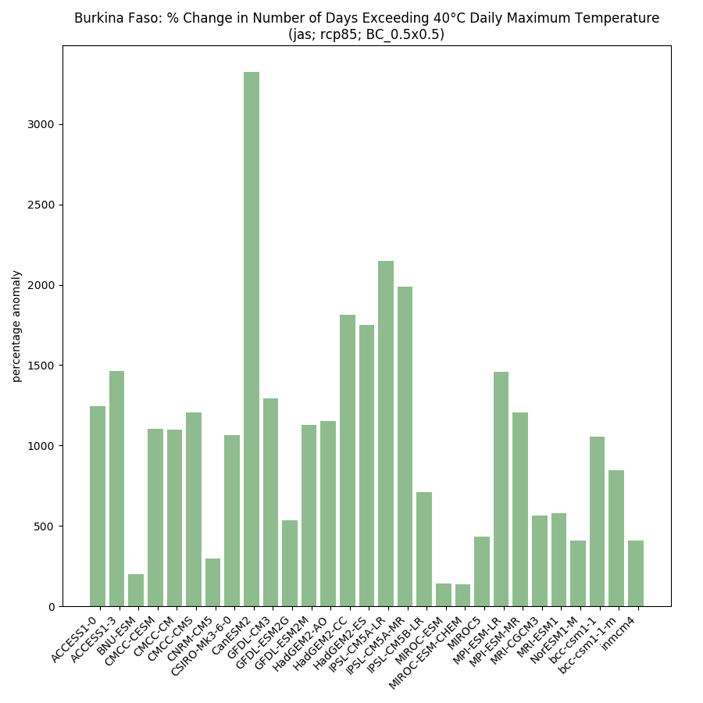

* As above, is it valid to show a % of a count?

### Historical vs scenarios side-by-side

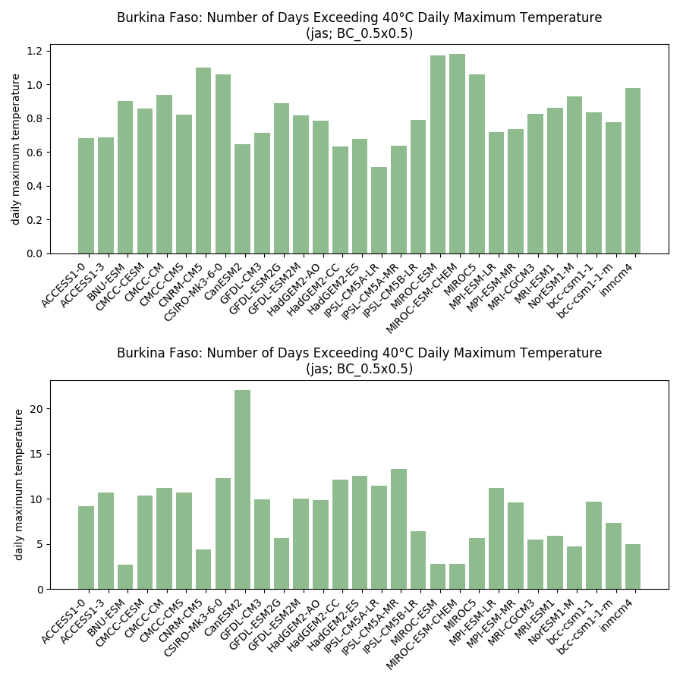

* Share the same y-axis between the two plots?
* Make sure the models match up between hist and all senarios
* Needs a figure title (similar to what’s already there), and subplot titles with only the scenario name (and possibly the climatology period)

## Model ranking scatterplots

### Each scenario (and historical) individually

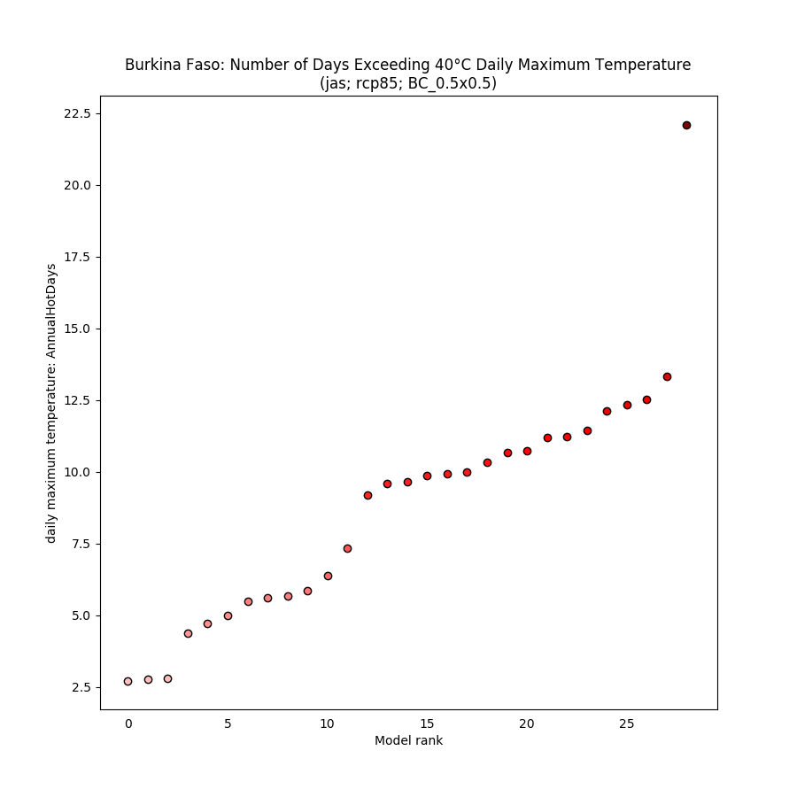

* Labelling the points could be interesting (but tricky!)
* How else can we make this look a bit more exciting?!
* Y-axis needs a better label
* Dave: As much as I like the rank scatters, again they duplicate info. Could keep them, and so just have a max of 2 plot styles that cut the data the same way? Or combine them with the box-and-whiskers: in the latter replace the vertical lines + tick marks with very steep rank scatters that have the xrange the same as the box width? I'll look back at the list of agreed plot types when I'm back in the office and see if I can remember why we thought both would be useful.
* Dave: Ways to make the rank scatter plots more interesting would be a combo of (a) larger dots, (b) no black edges for dots, and (c) multiple small panels (scenarios, dataset etc) on one page.

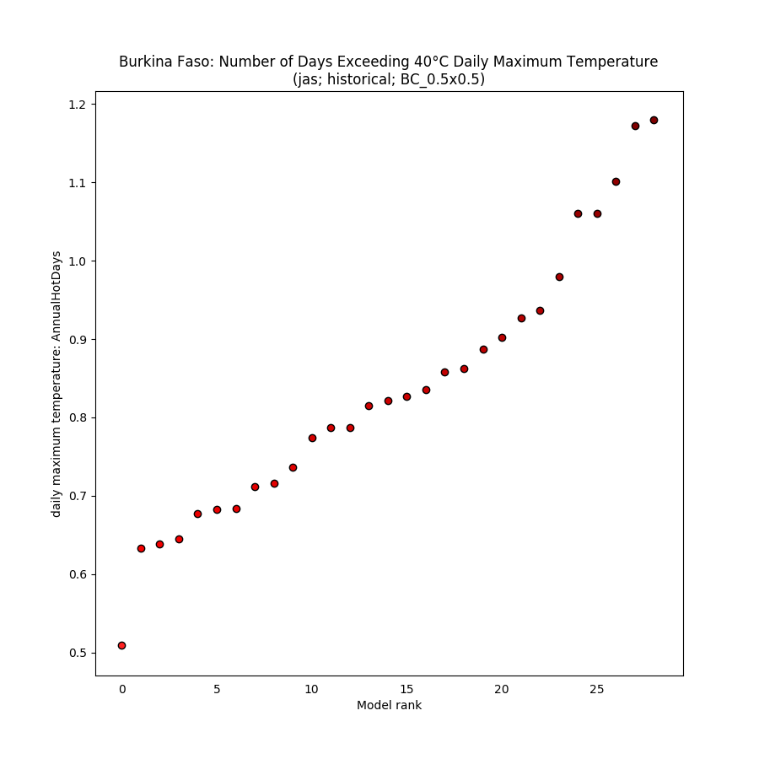

### Absolute anomaly (one scenario)

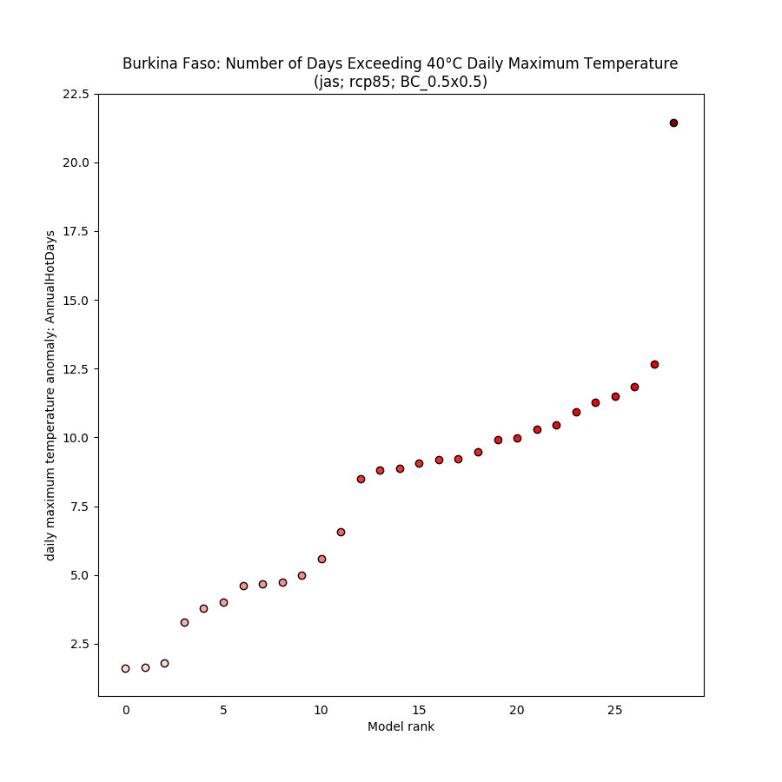

### % anomaly (one scenario)

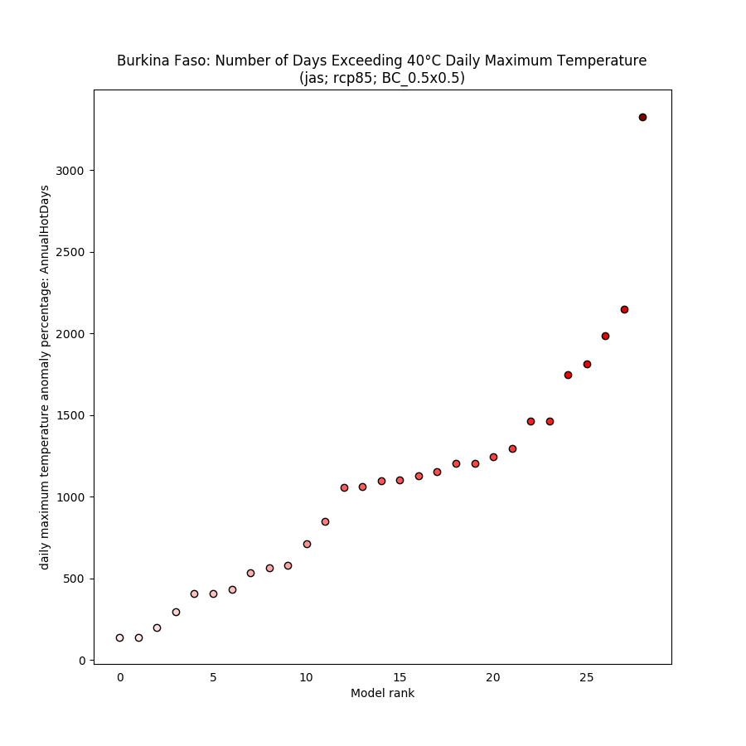

## Spaghetti timeseries

### All scenarios for 1950-2100

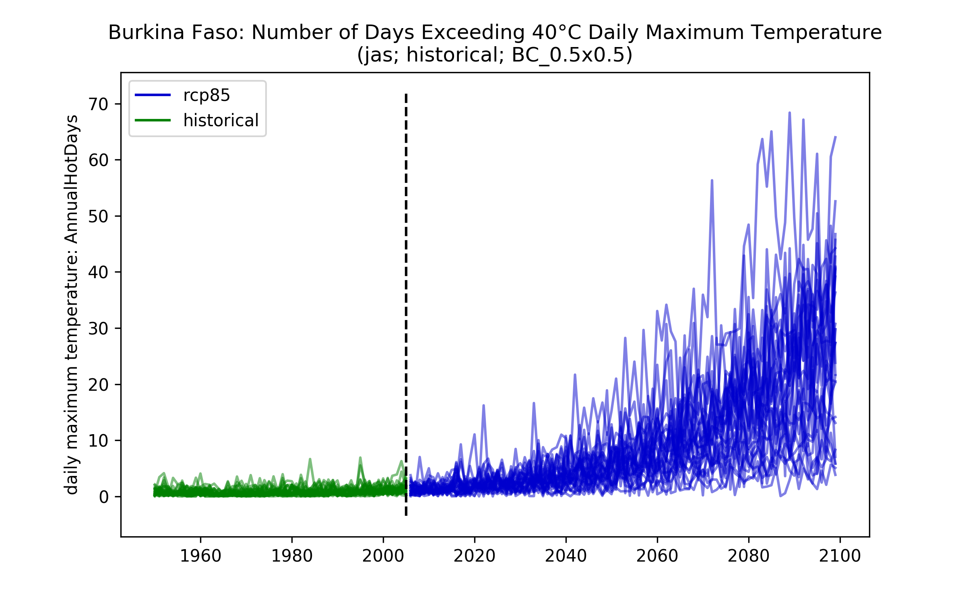

* One plot per scenario – might be useful to plot the 10th and 90th percentiles on here?
* Could we combine the 10-90th p/c for all scenarios on to one plot?
* Y-axis needs fixing
* X-axis label?
* Dave: Again, unless I asked for this and have forgotten I asked for it (and why I asked for it), I'd like to remove this. Its reliable info content is duplicated in other plots, and plotting data for individual years is of course unreliable and I think will mislead some.

## Maps of ensemble spread (10th and 90th percentiles)

### Each scenario (and historical) individually

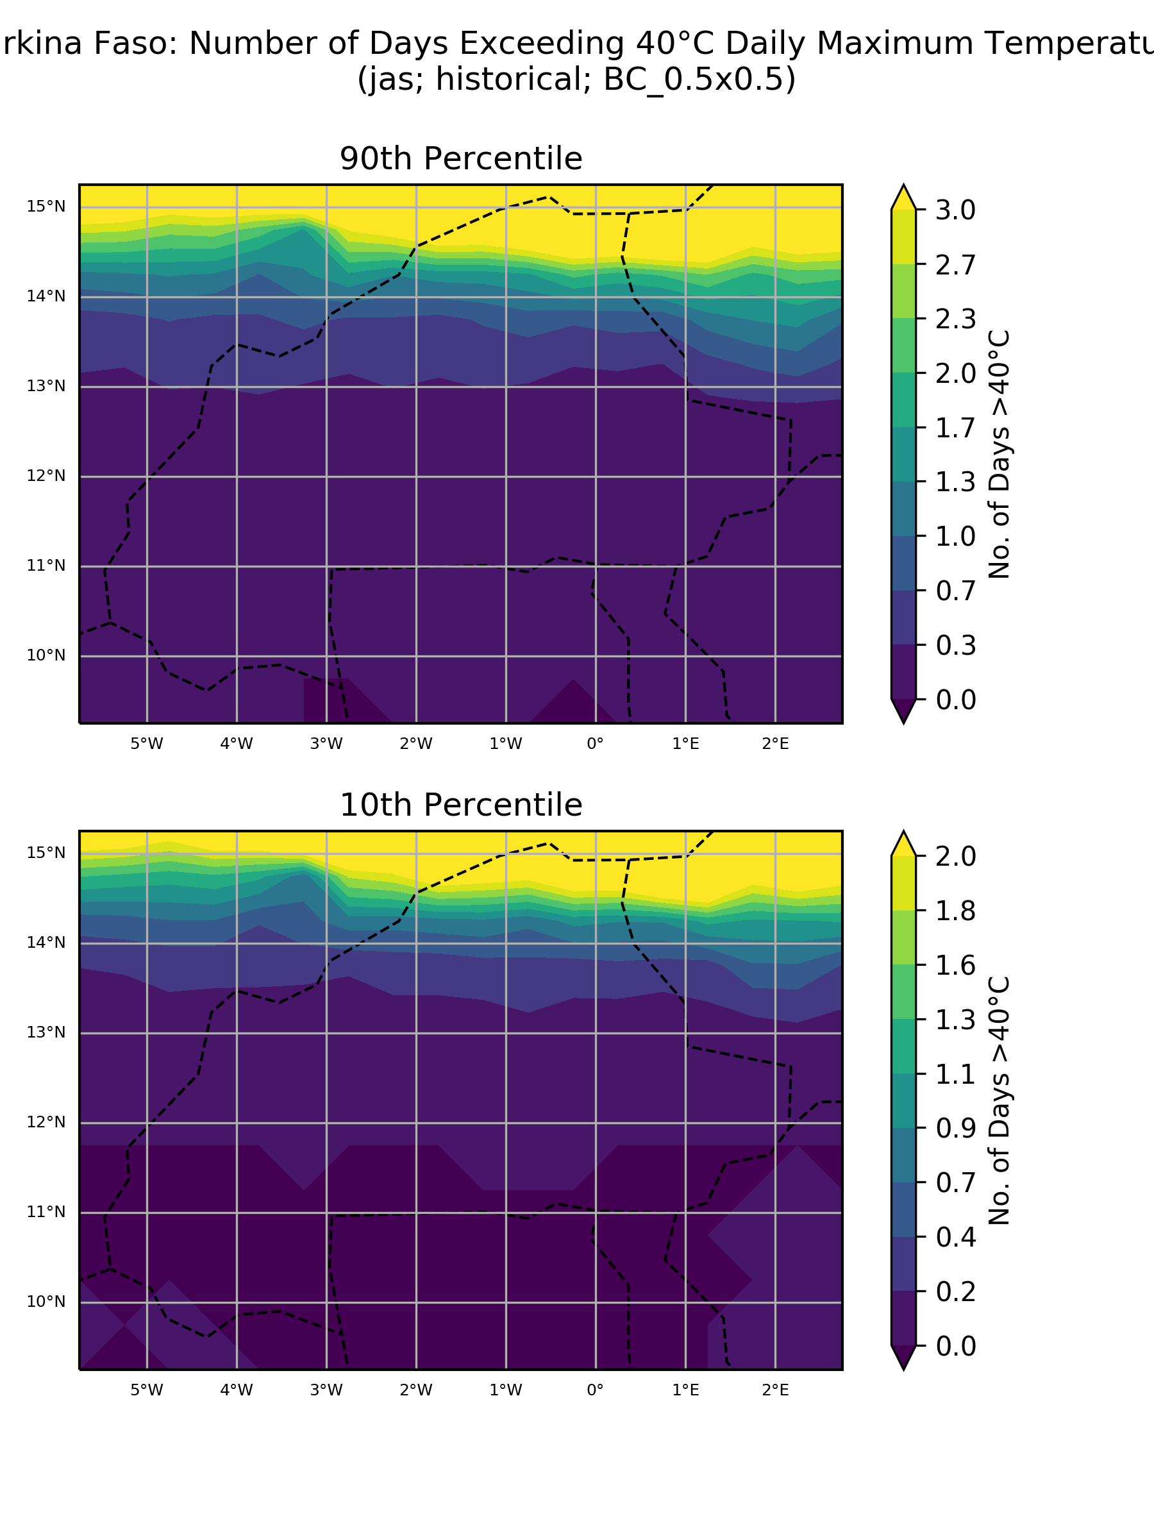

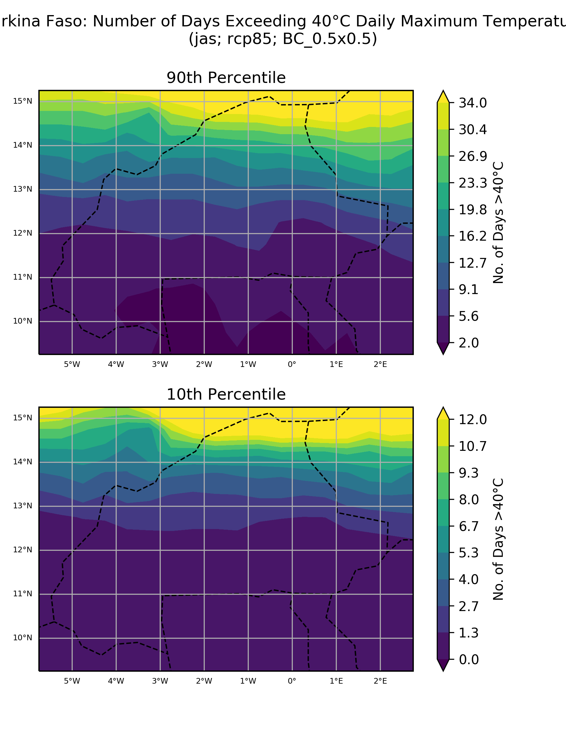

* Same colour scale for 10 and 90th percentiles? Same also for hist-rcp comparison?
* Title over-shoot
* Cities or sub-regions?
* Dave: Need to explain 10th and 90th percentiles, that they are in model space which will not be what readers have experience of. And agree need same col scale for each. And agree need city and/or sub-national boundaries for context.

### Absolute anomaly (one scenario)

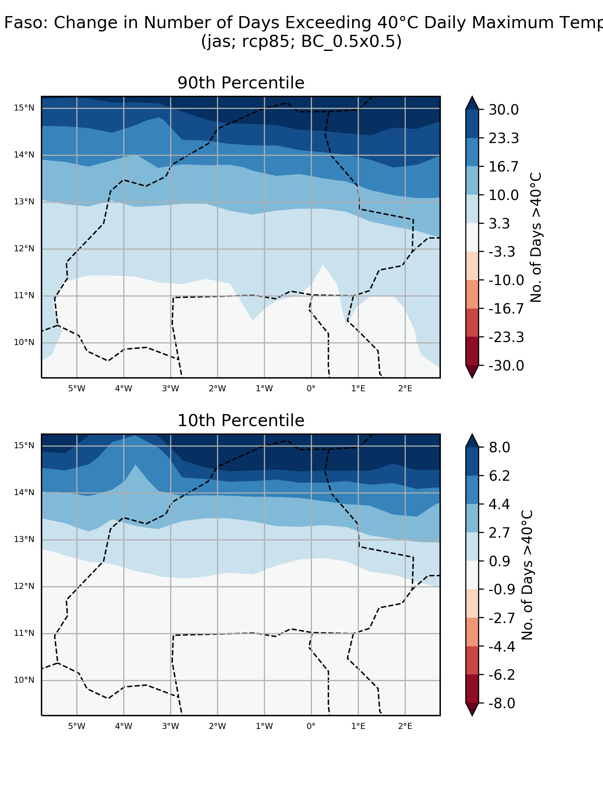

* Title over-shoot
* Same colour scale needed

### % anomaly (one scenario)

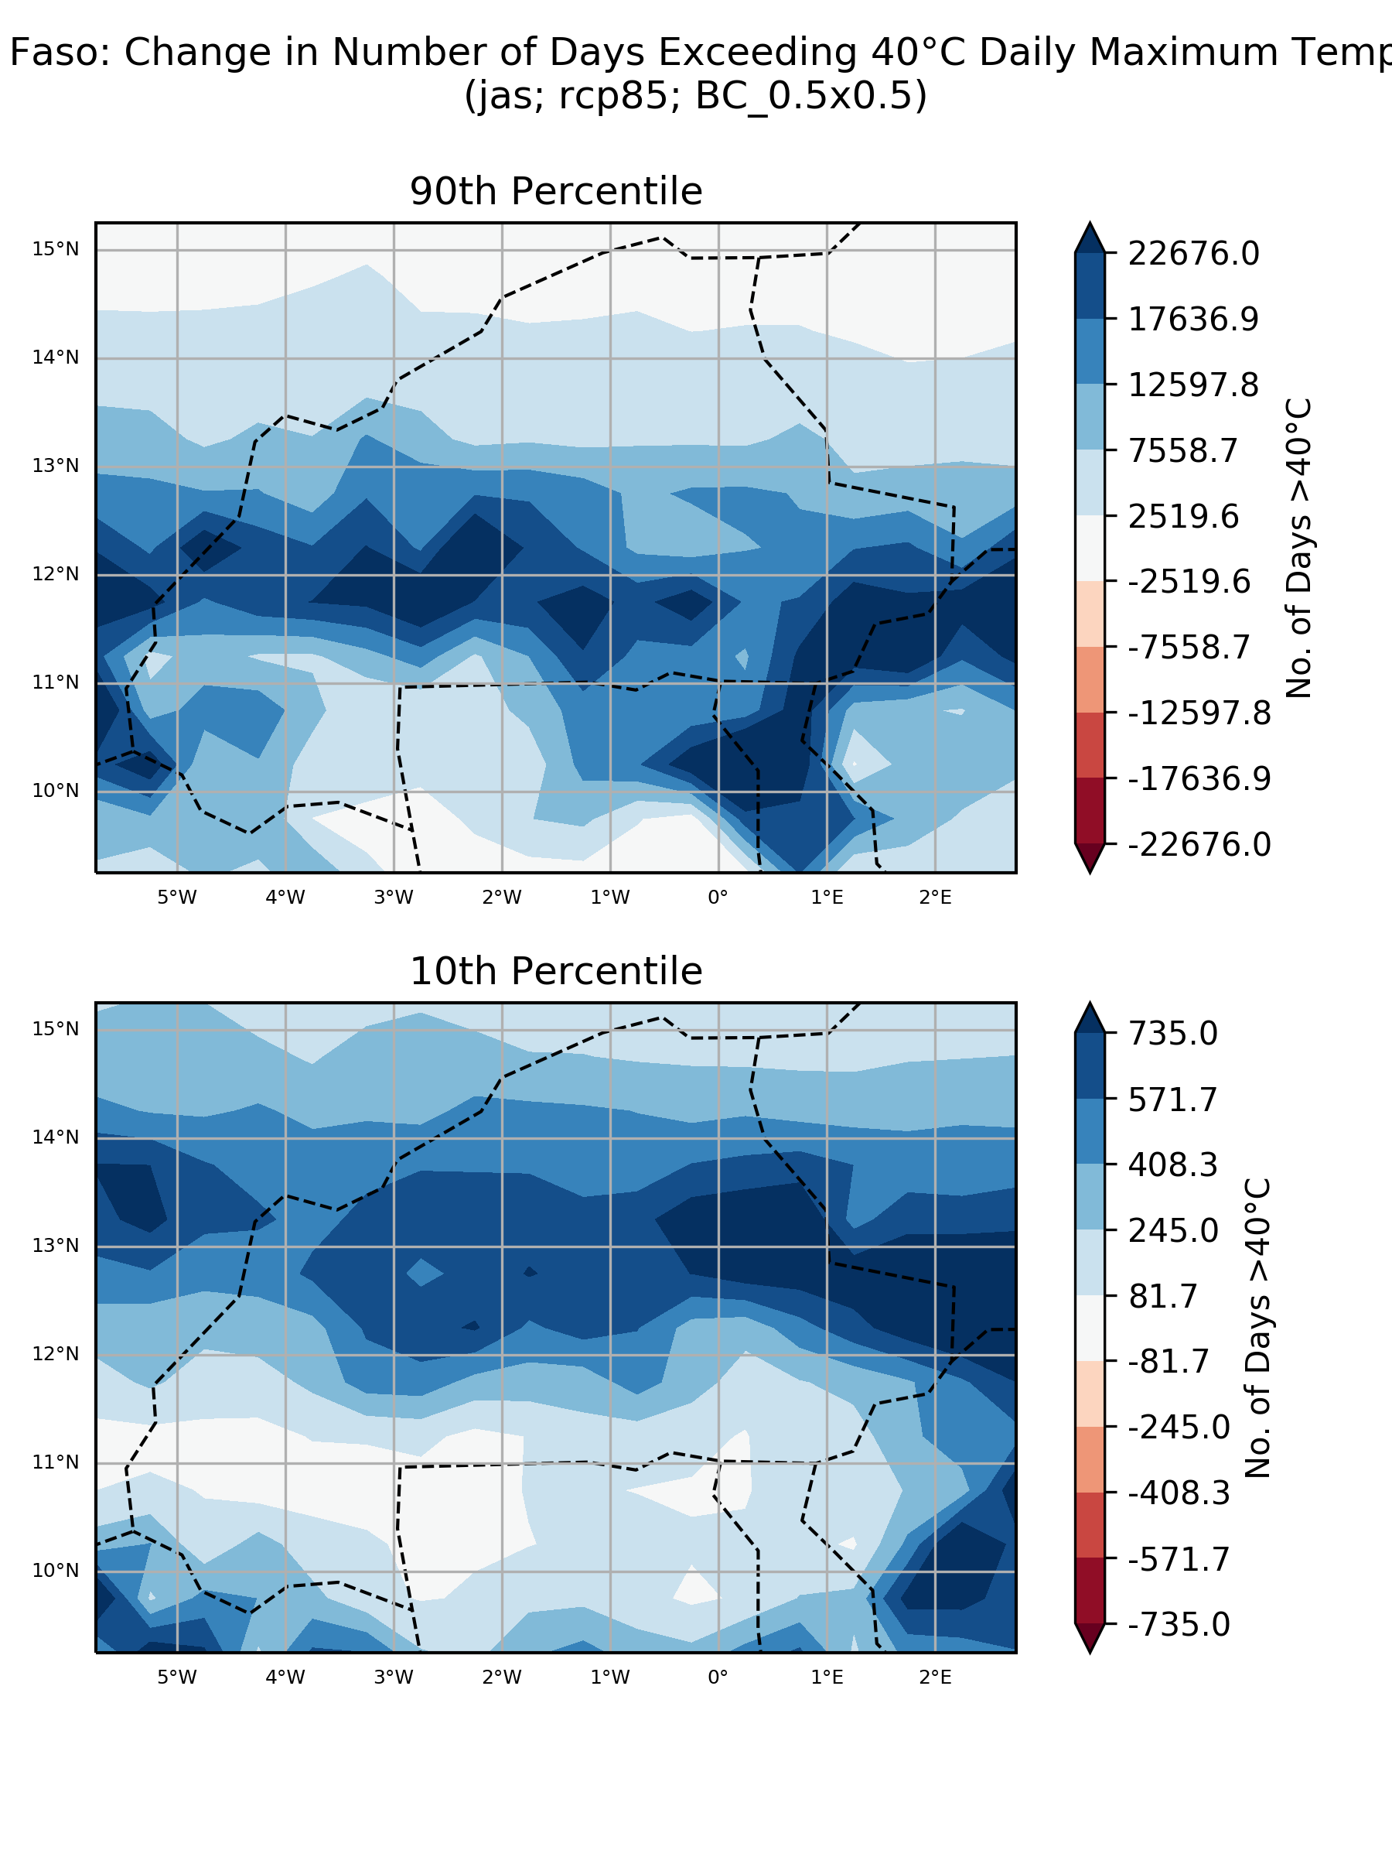

## ‘Number of model’ histograms

### Absolute anomaly (one scenario)

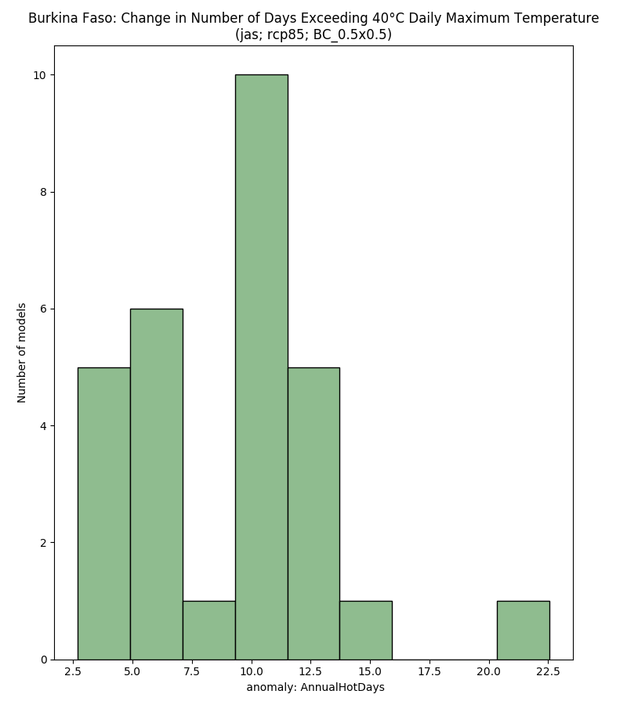

* X-axis label needed
* Colours a bit boring?
* X-axis tick marks don’t match up with bars
* Dave: Remove 'number of model' histograms as extra to spec, not adding important extra info so confusing readers, and making the atlas over-sized
  + Andy: I disagree – I think they add some important summary information that is not found in any other plot!

### % anomaly (one scenario)

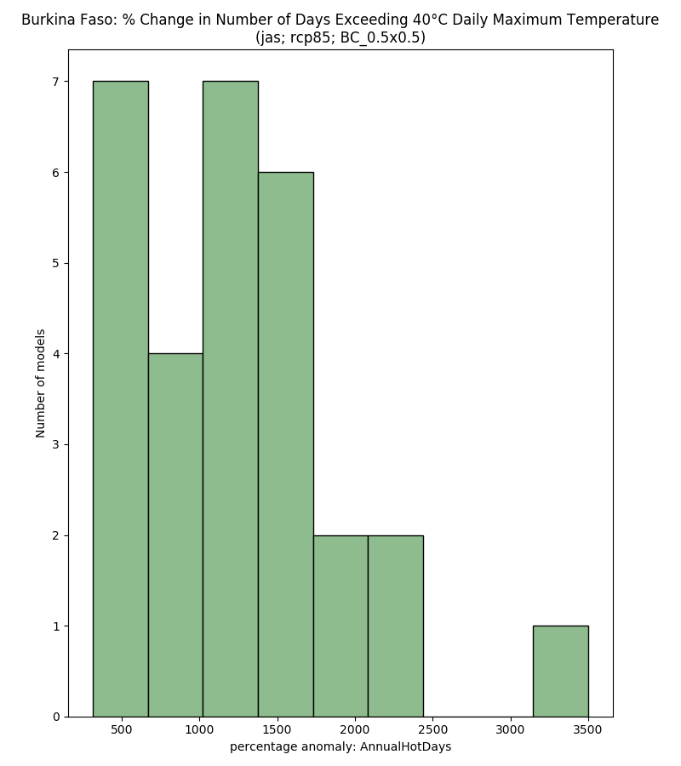

# Maximum Seasonal Precipitation

## Boxplots

### Absolute anomaly by scenario

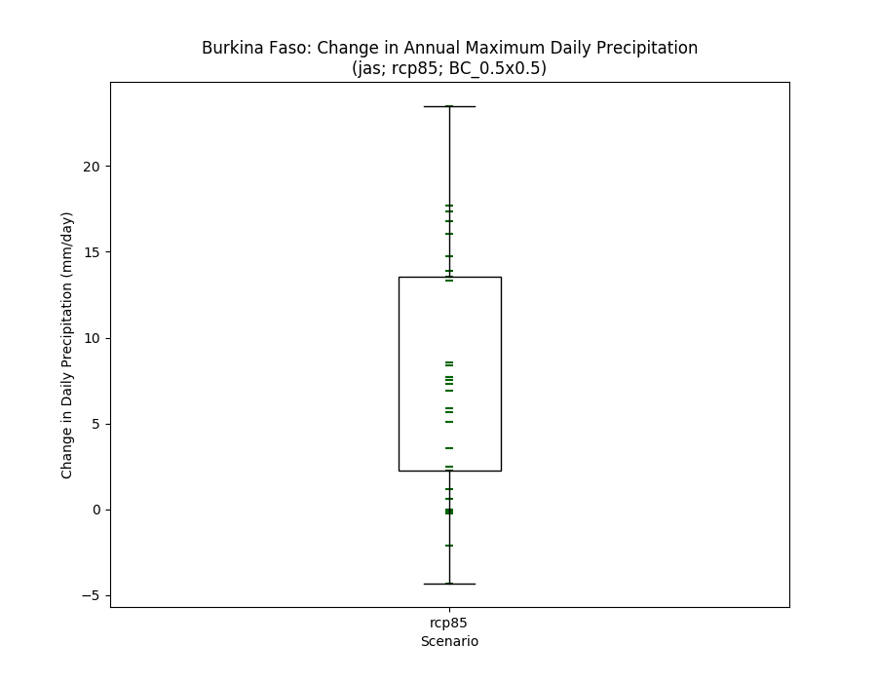

### % anomaly by scenario

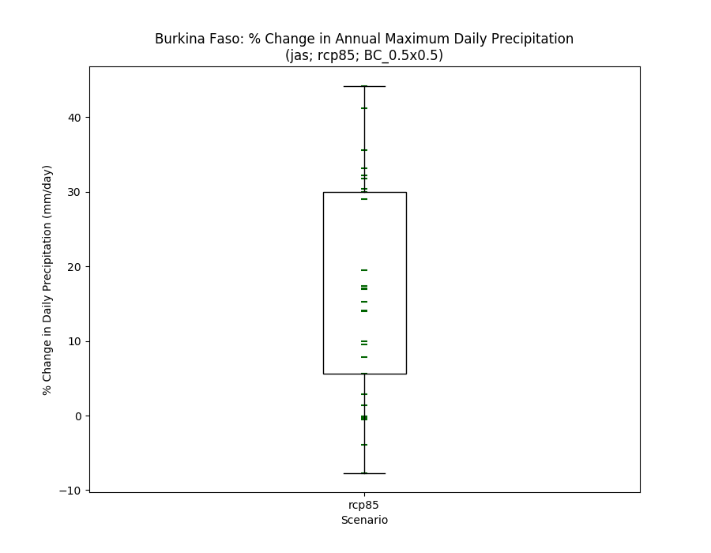

### Historical vs scenarios

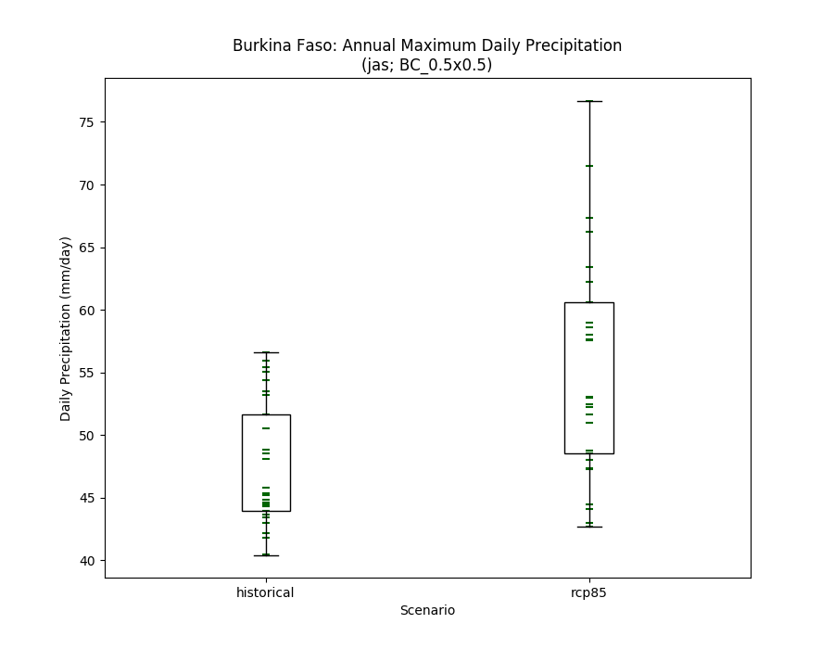

## Histograms

### Absolute anomaly (one scenario)

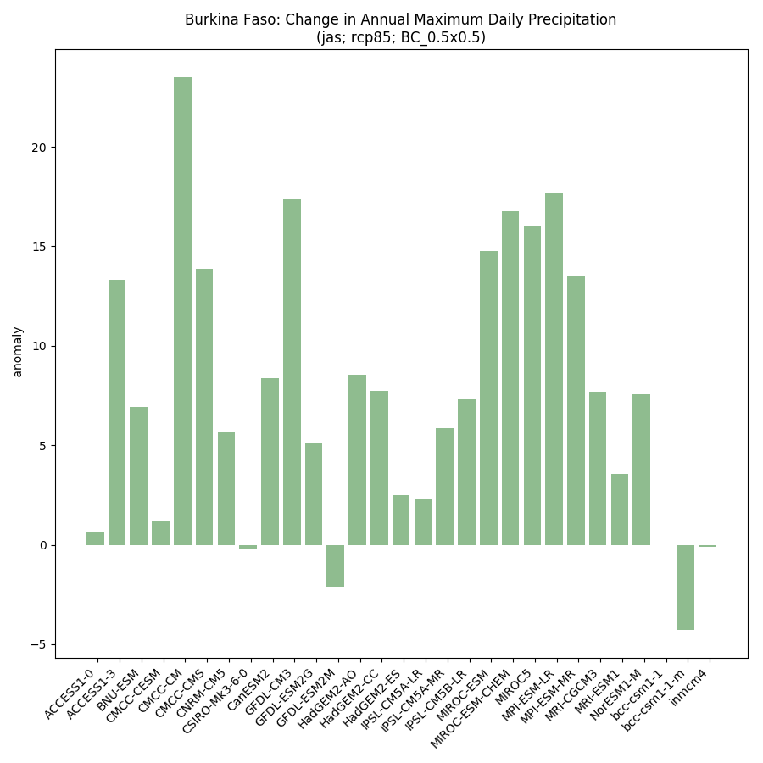

### % anomaly by scenario

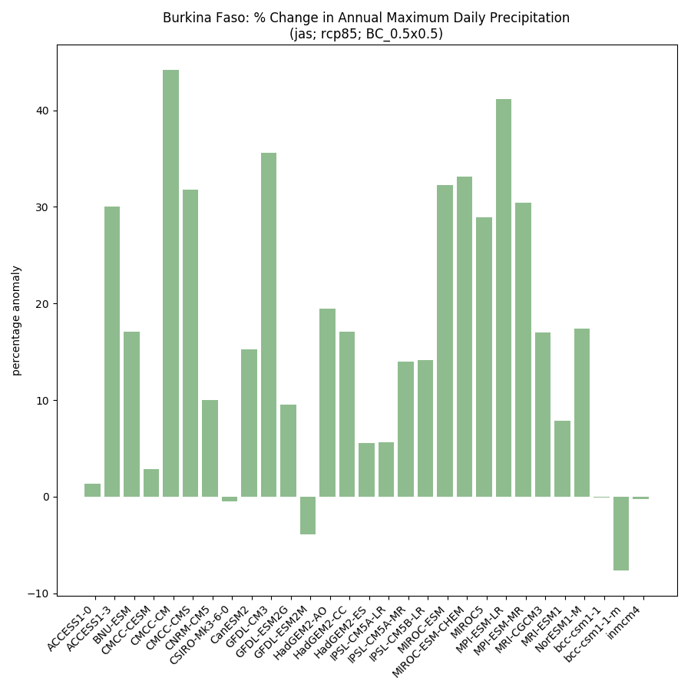

### Historical vs scenarios side-by-side

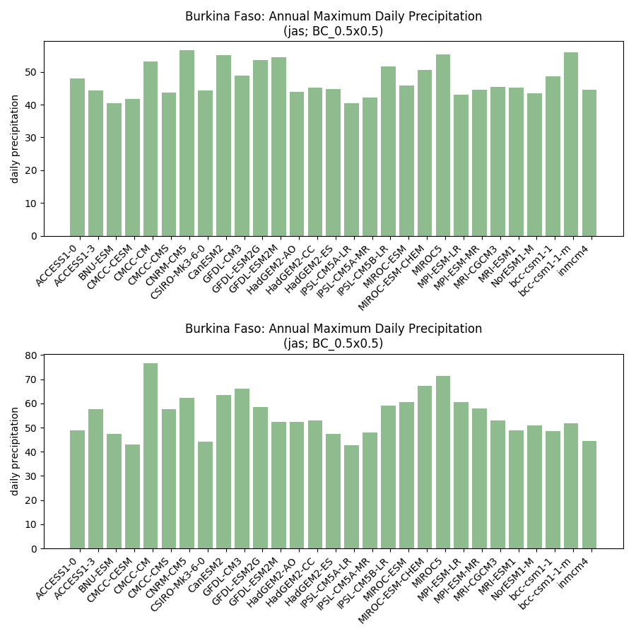

## Model ranking scatterplots

### Each scenario (and historical) individually

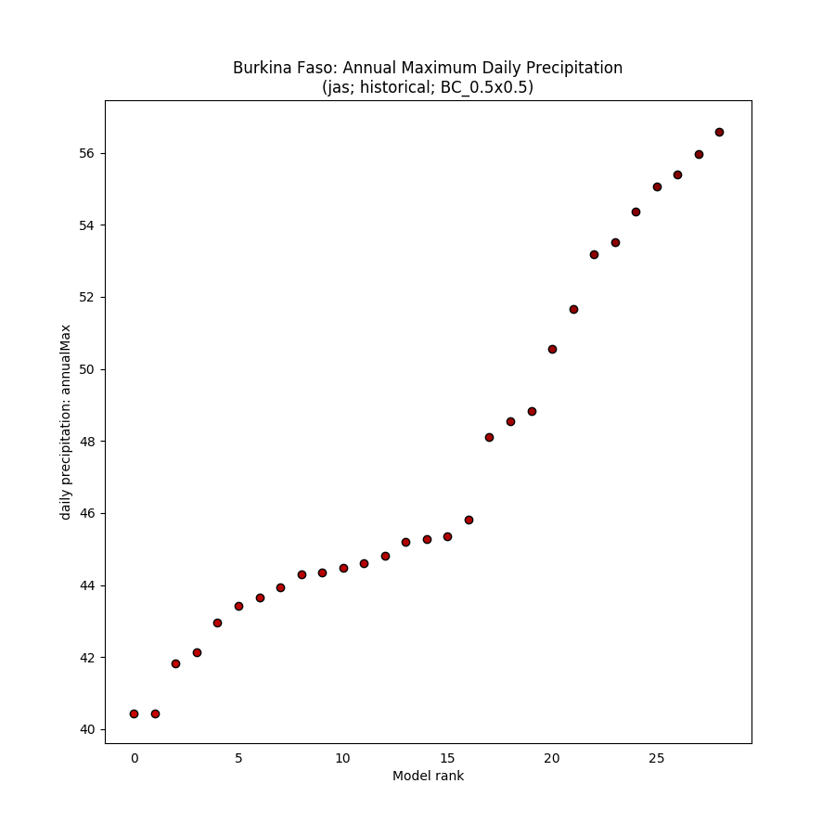

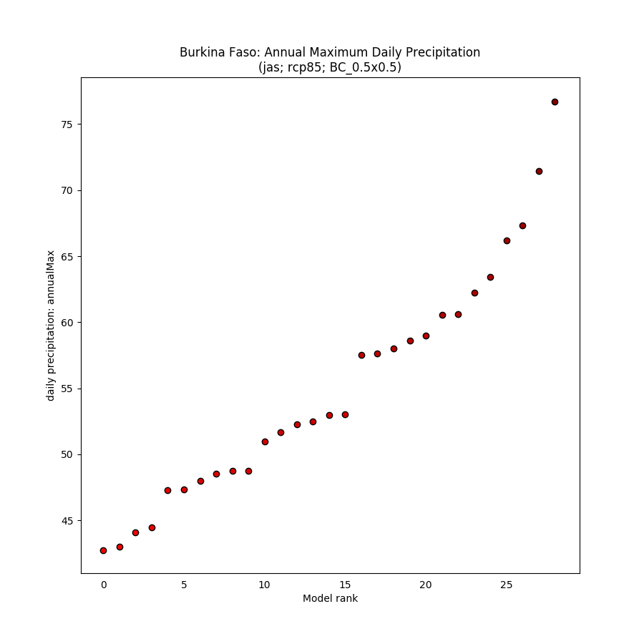

### Absolute anomaly (one scenario)

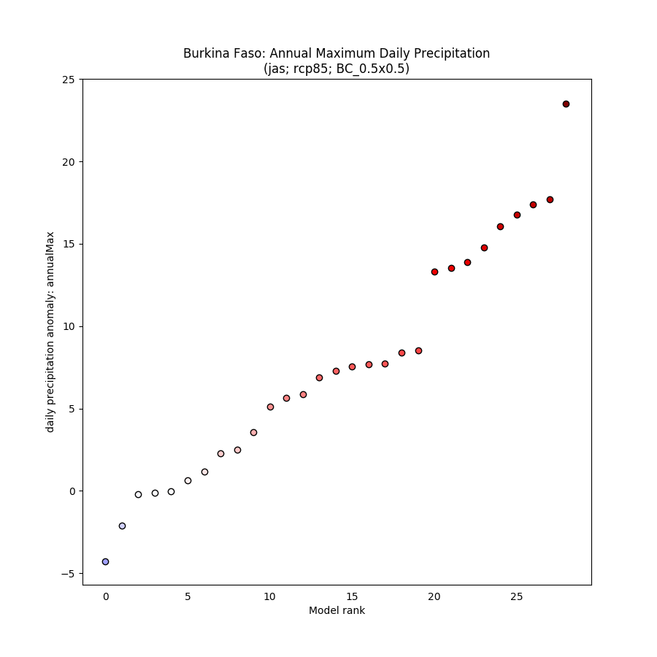

### % anomaly (one scenario)

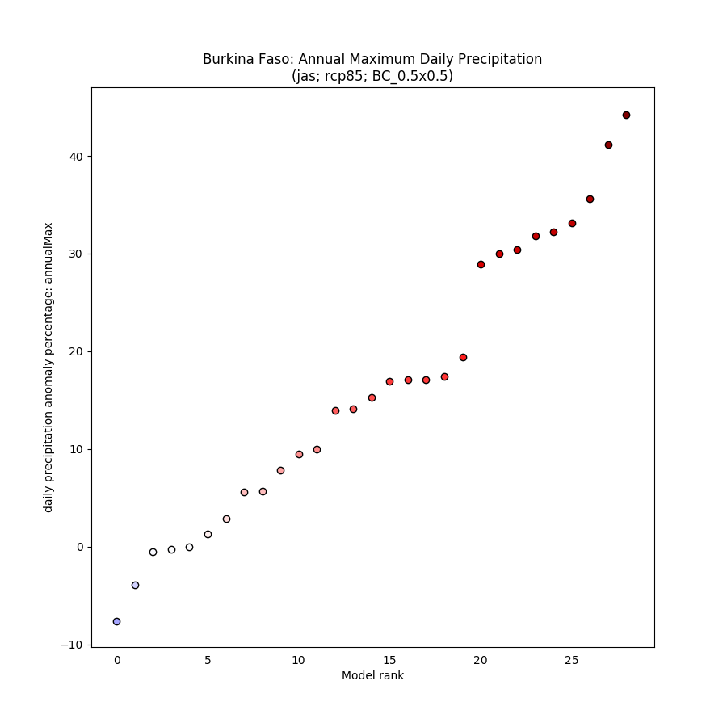

## Spaghetti timeseries

### All scenarios for 1950-2100

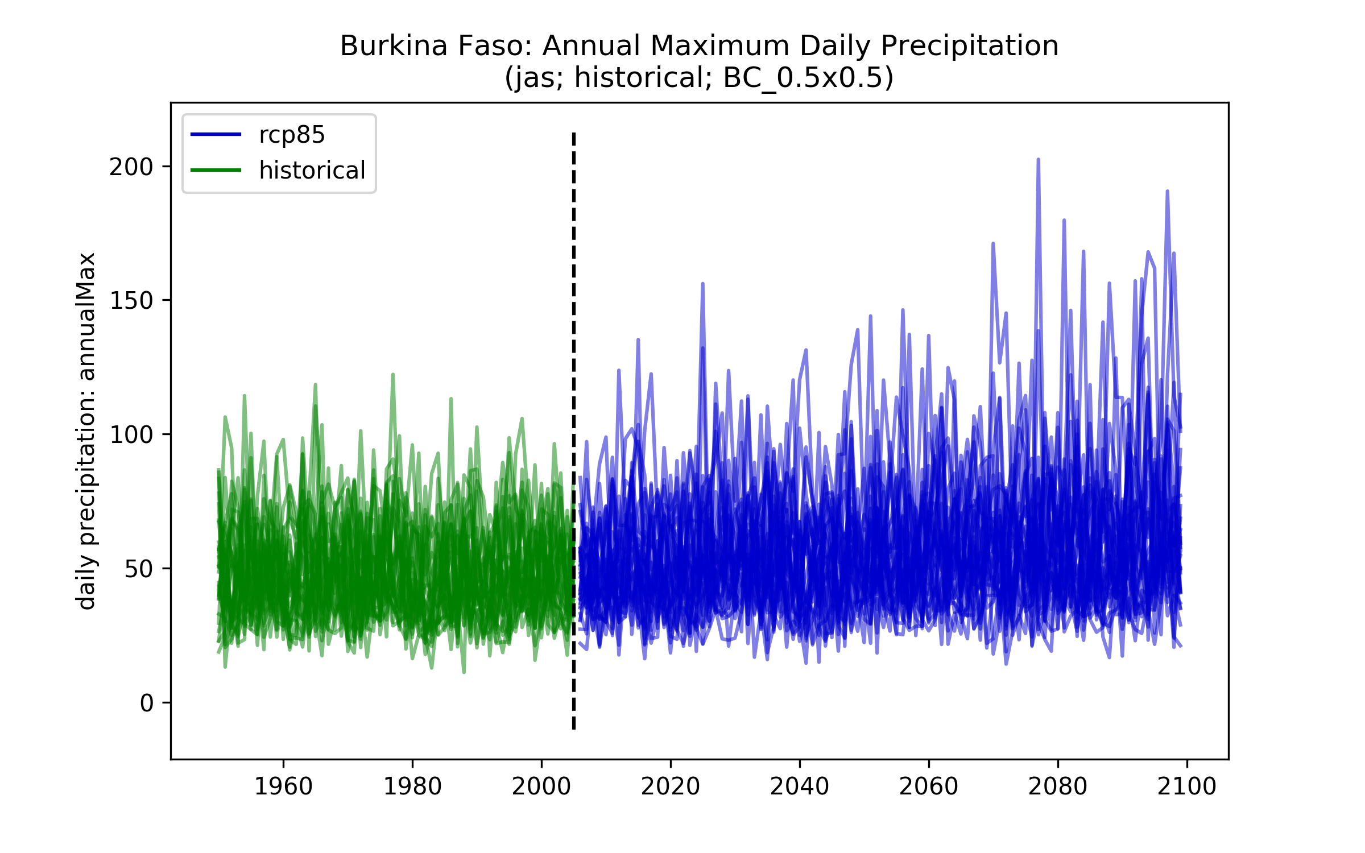

## Maps of ensemble spread (10th and 90th percentiles)

### Each scenario (and historical) individually

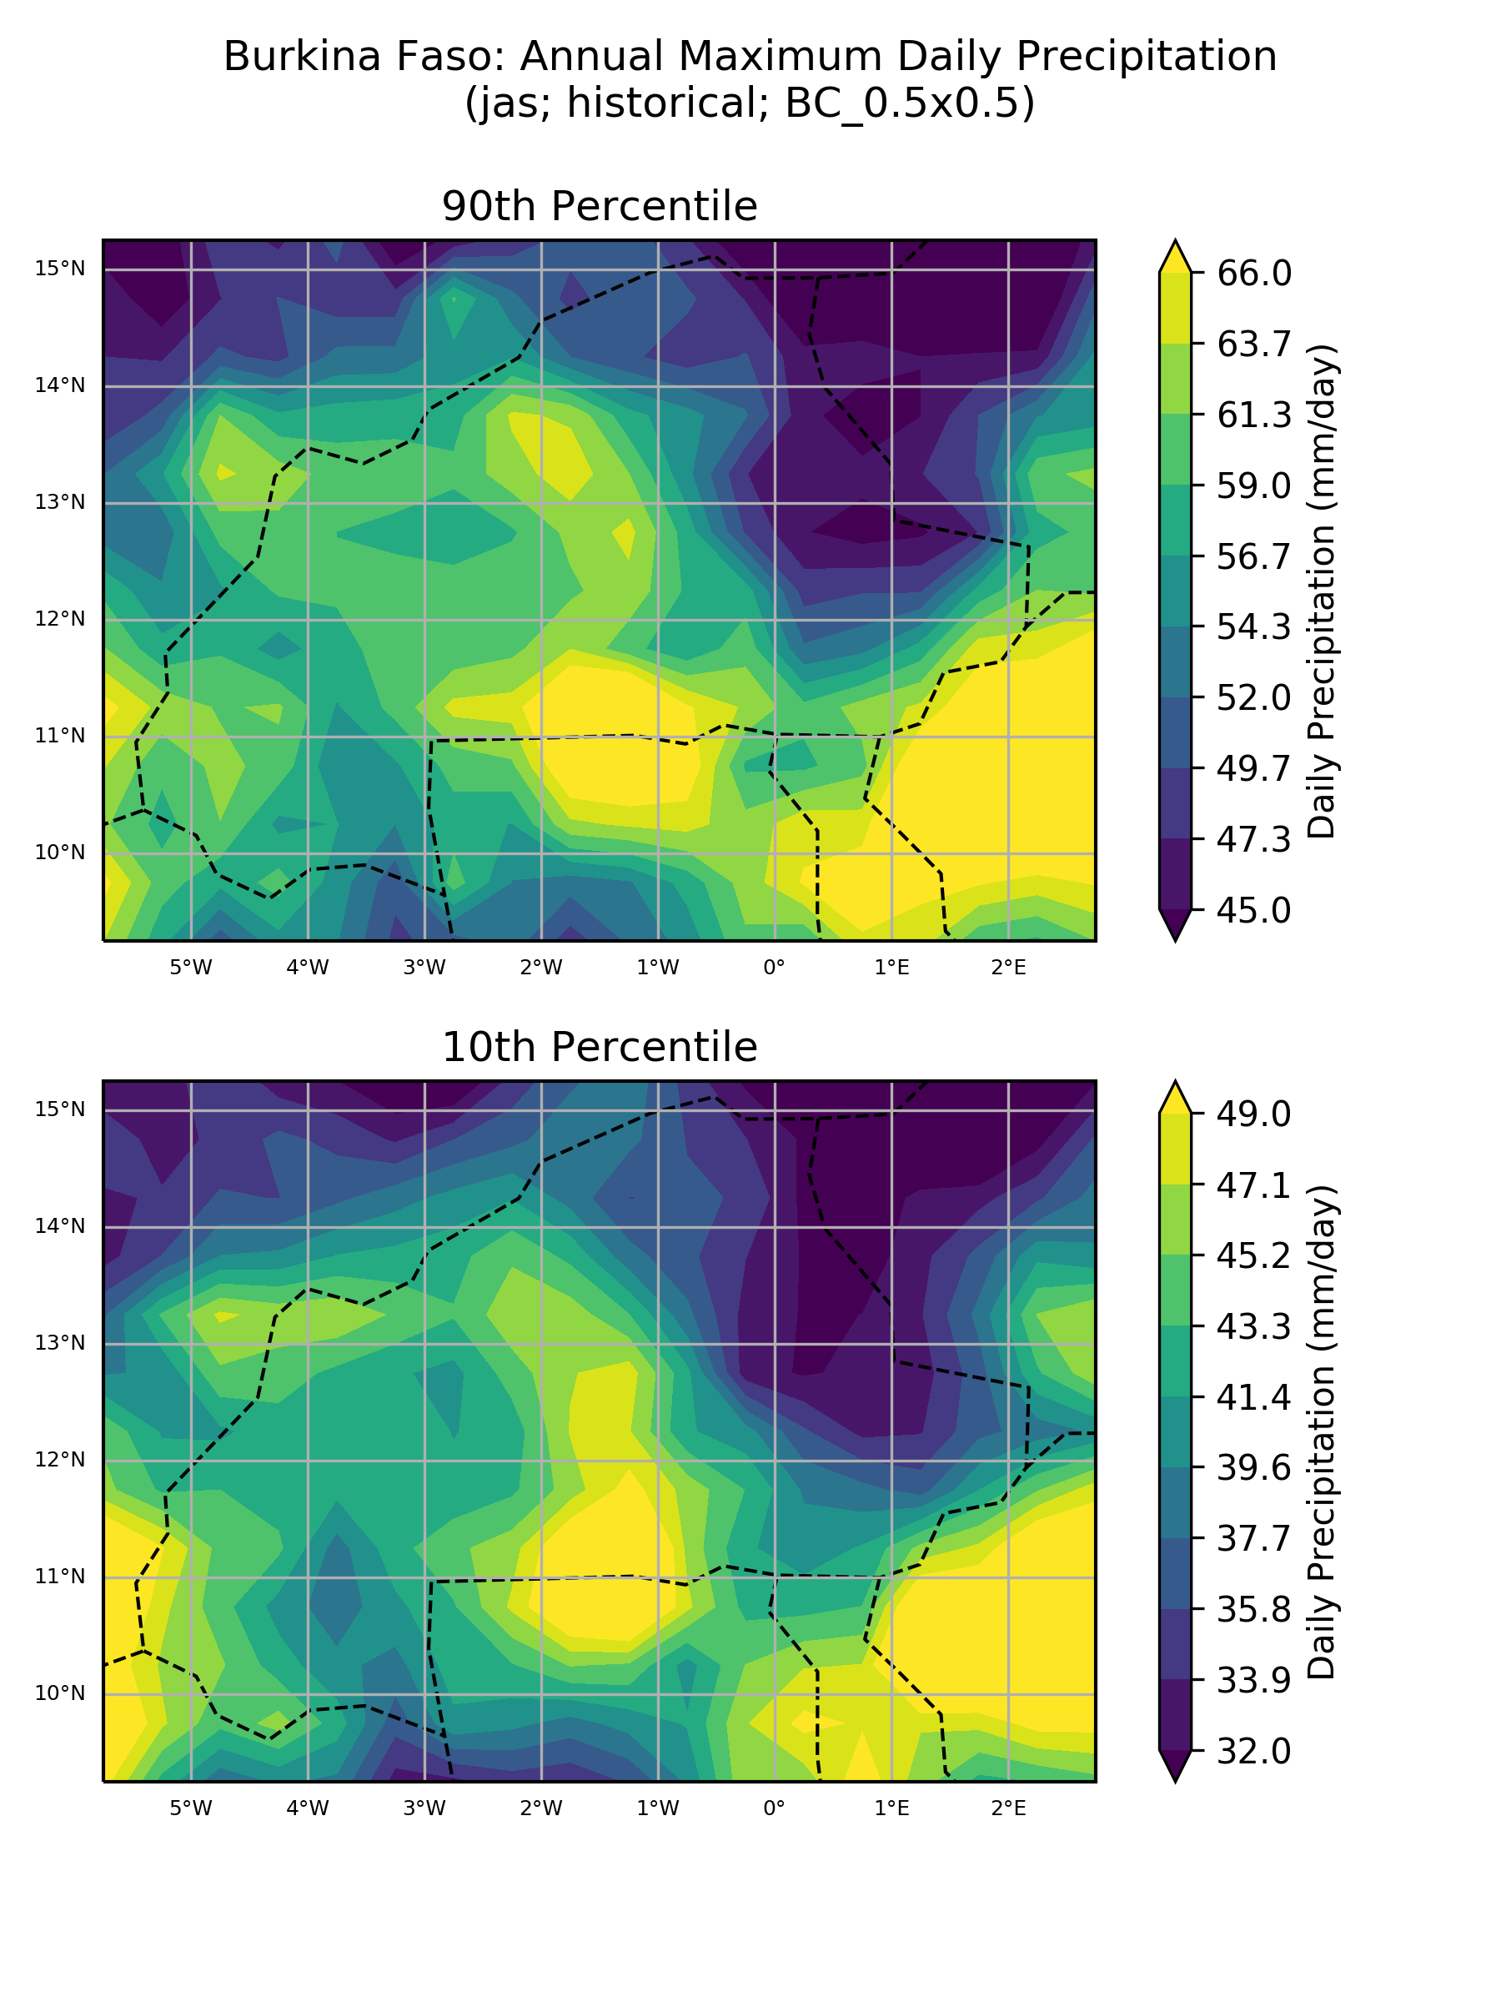

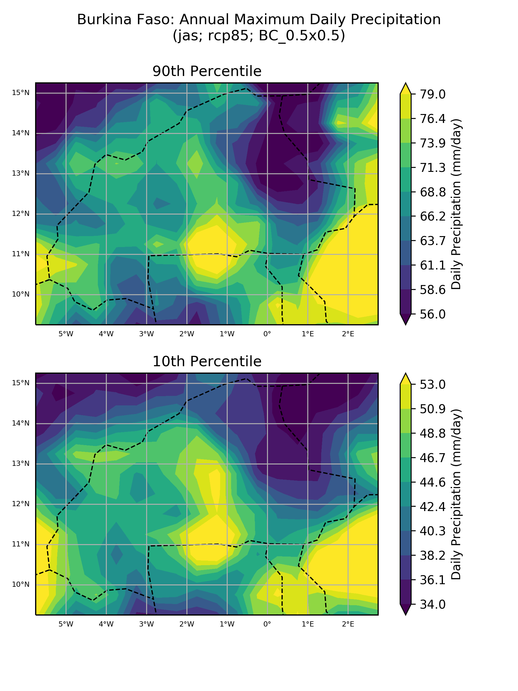

### Absolute anomaly (one scenario)

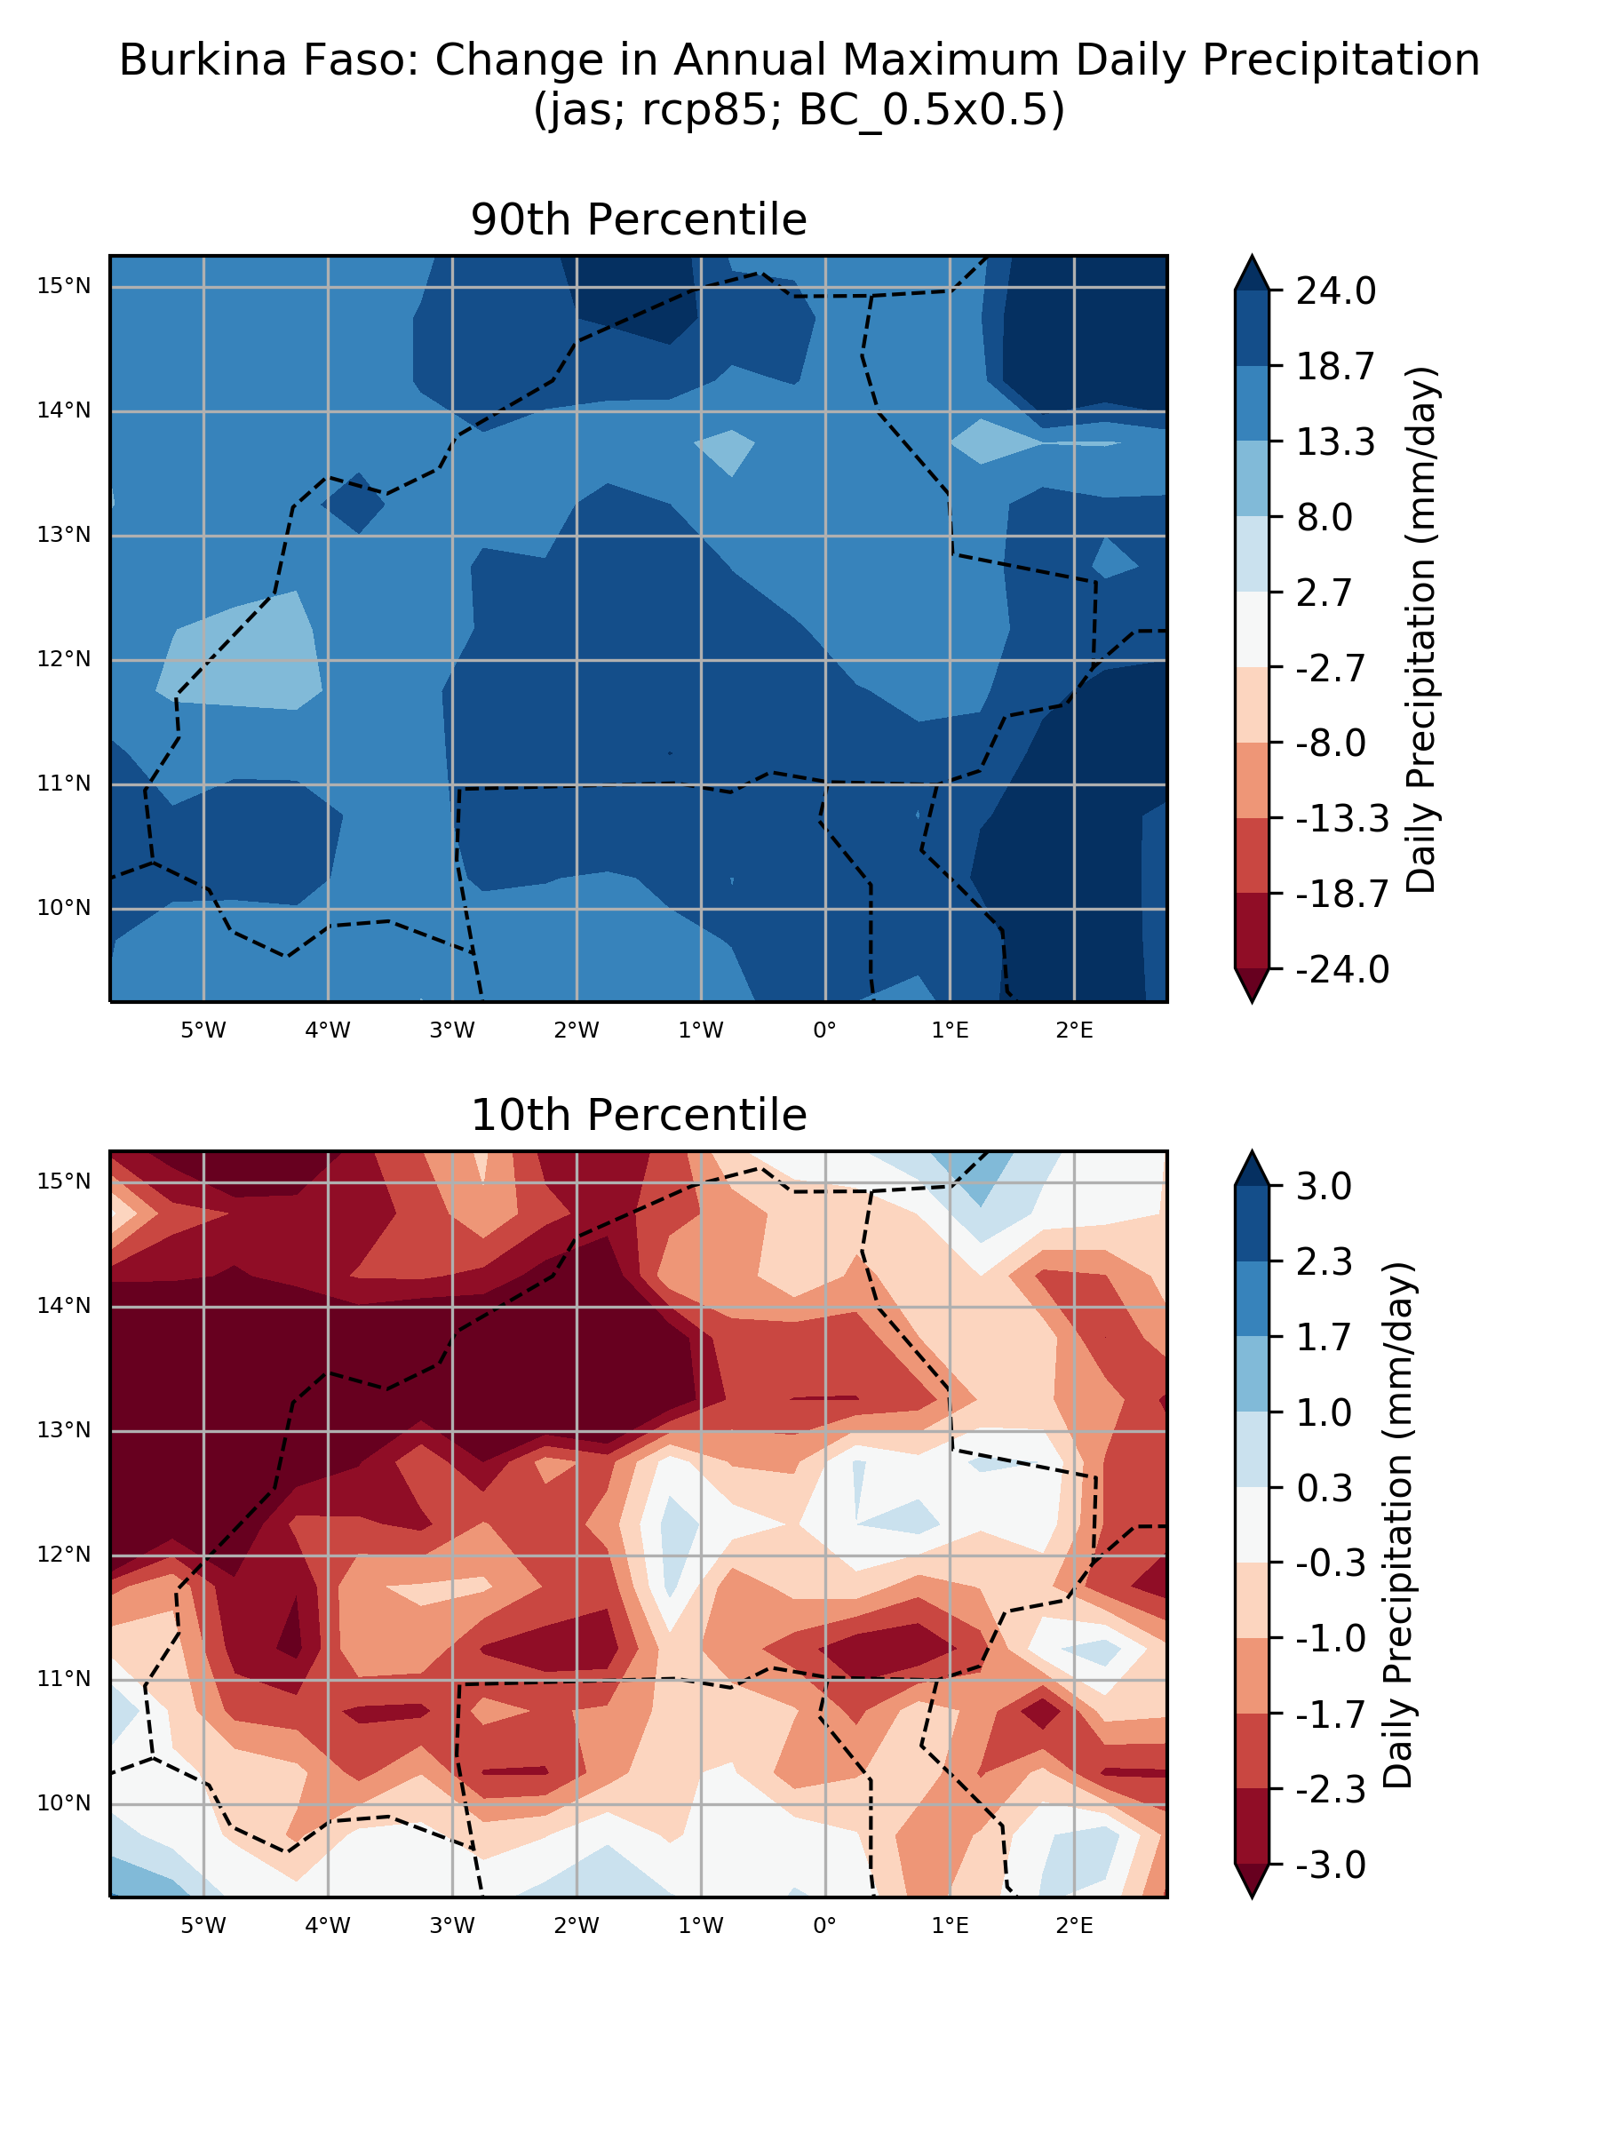

### % anomaly (one scenario)

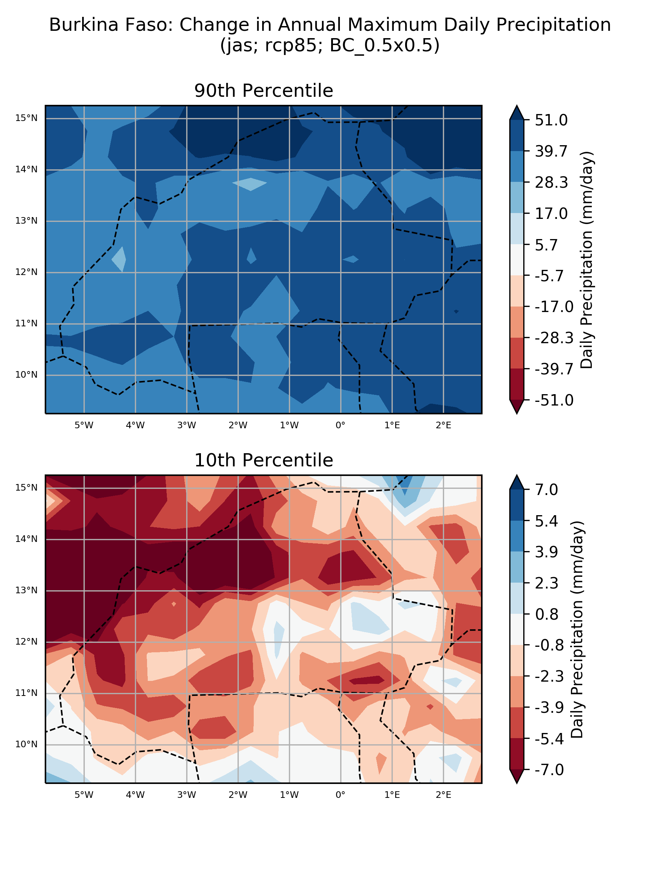

## ‘Number of model’ histograms

### Absolute anomaly (one scenario)

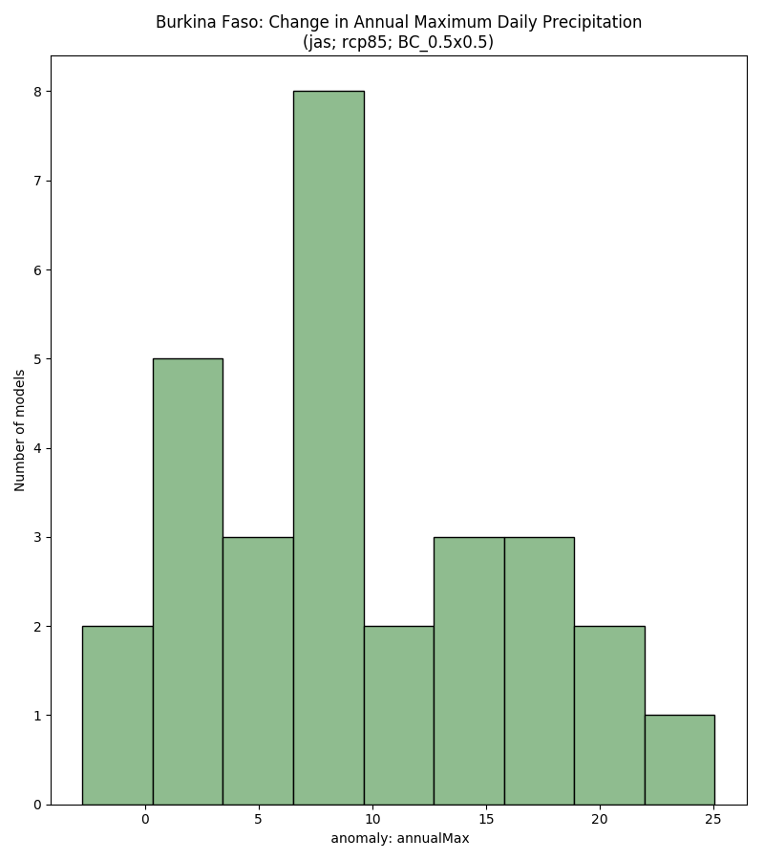

### % anomaly (one scenario)

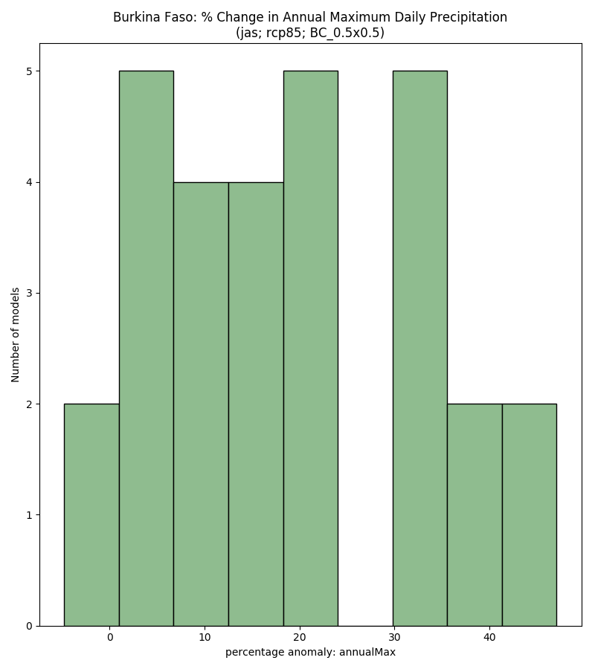

# Monsoon Onset (Marteau method)

## Boxplots

### Absolute anomaly by scenario

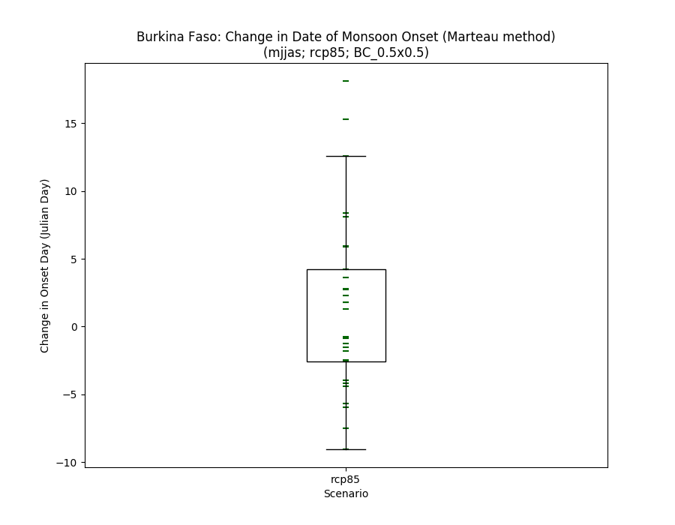

### % anomaly by scenario

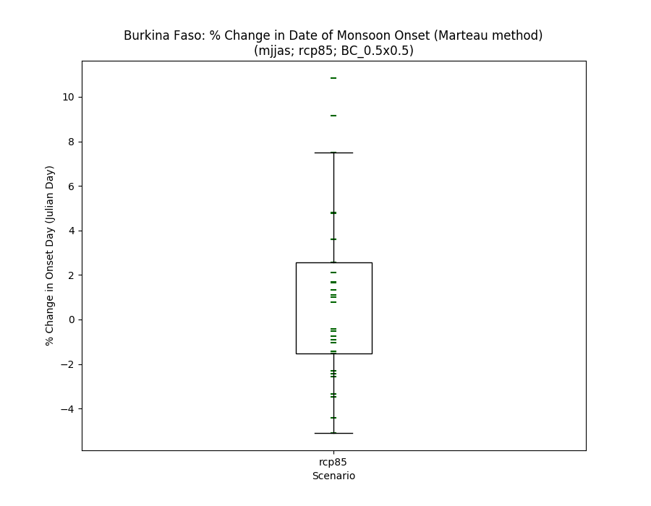

### Historical vs scenarios

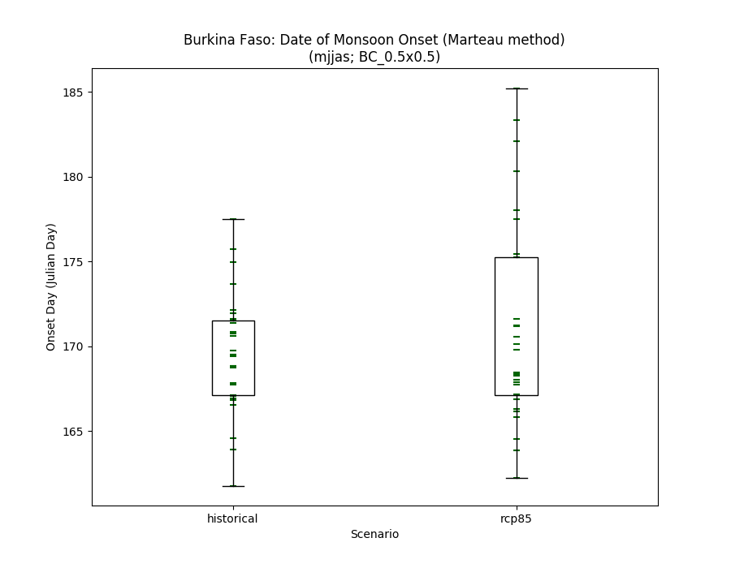

## Histograms

### Absolute anomaly (one scenario)

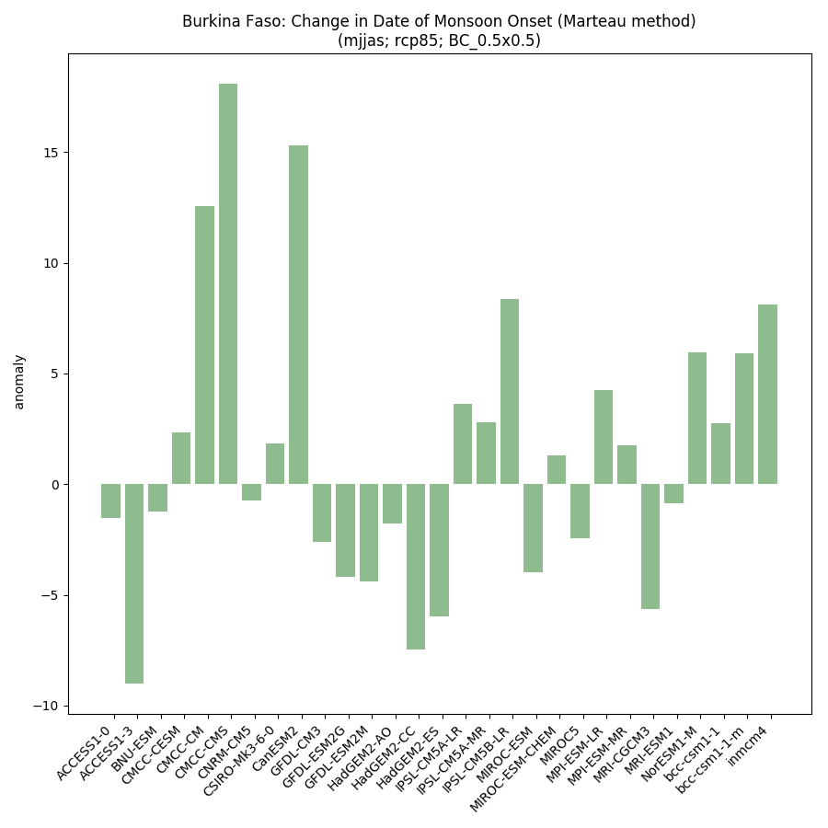

### % anomaly by scenario

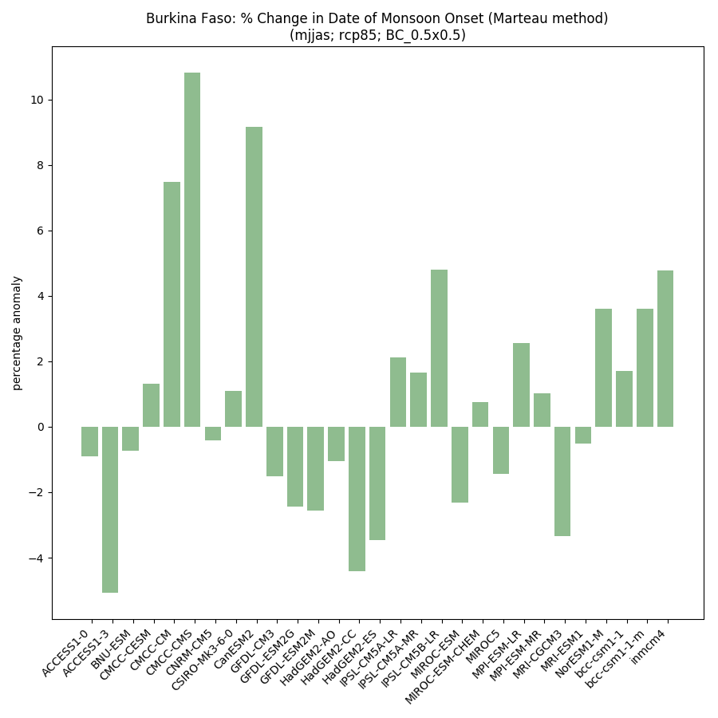

### Historical vs scenarios side-by-side

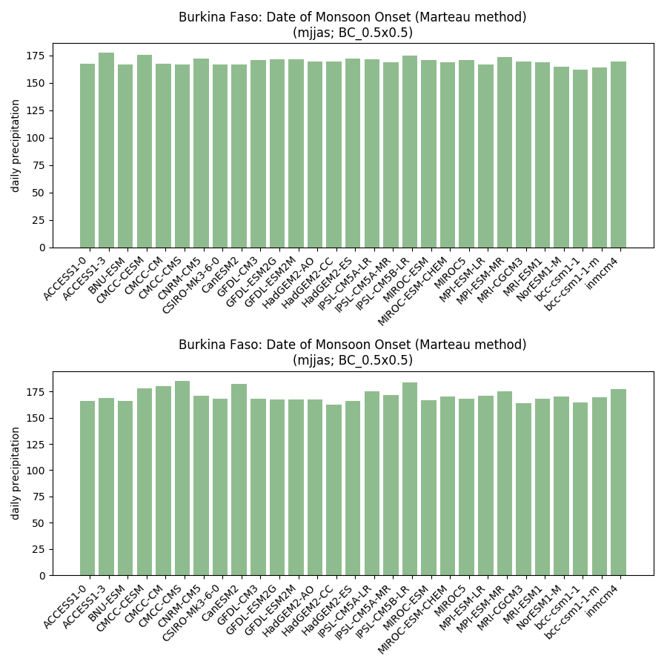

## Model ranking scatterplots

### Each scenario (and historical) individually

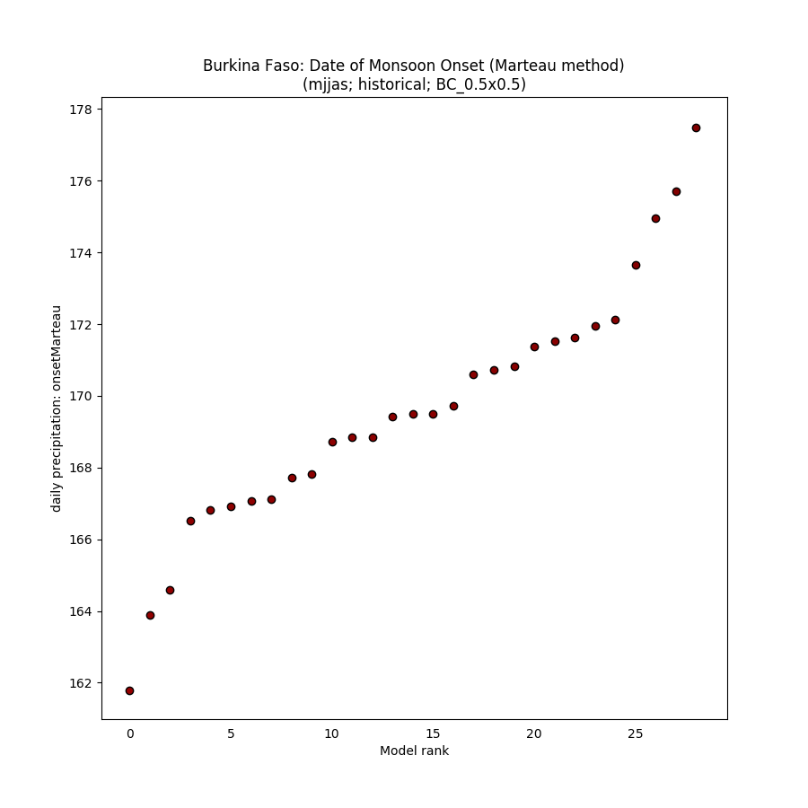

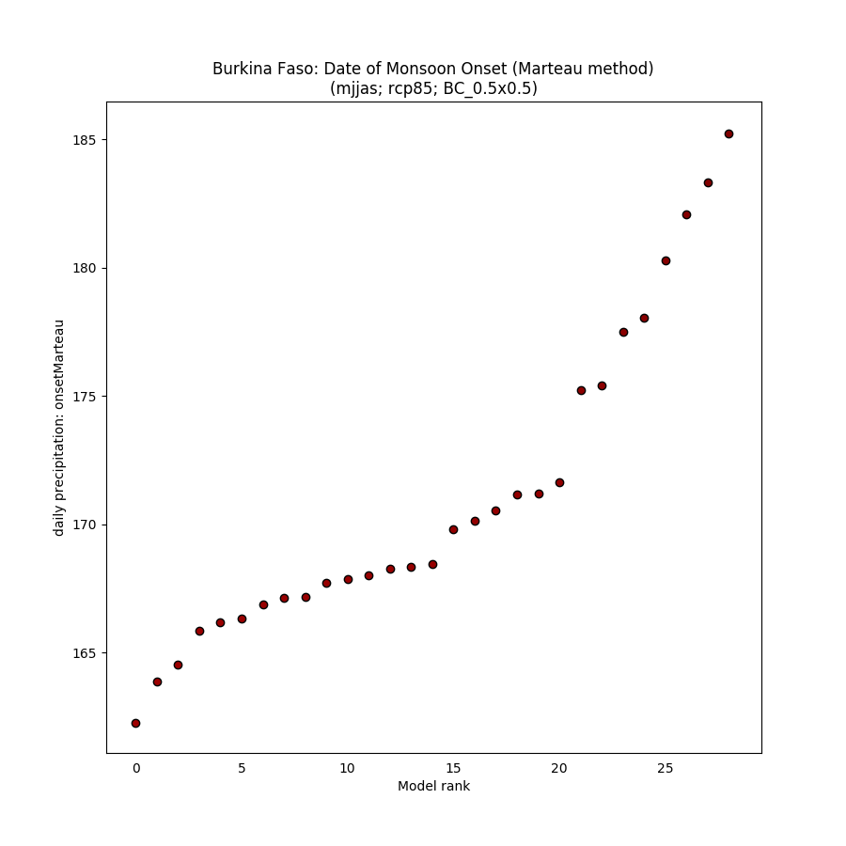

### Absolute anomaly (one scenario)

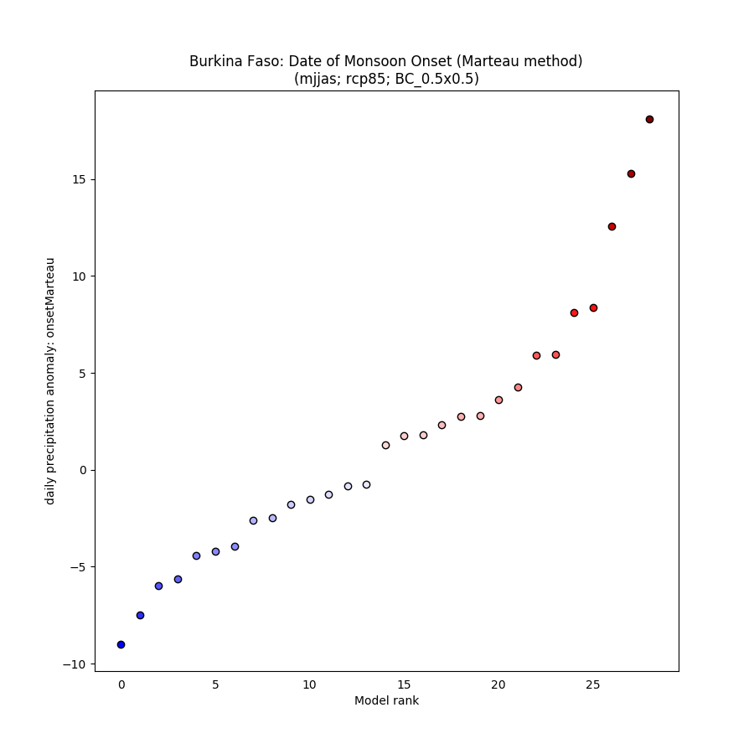

### % anomaly (one scenario)

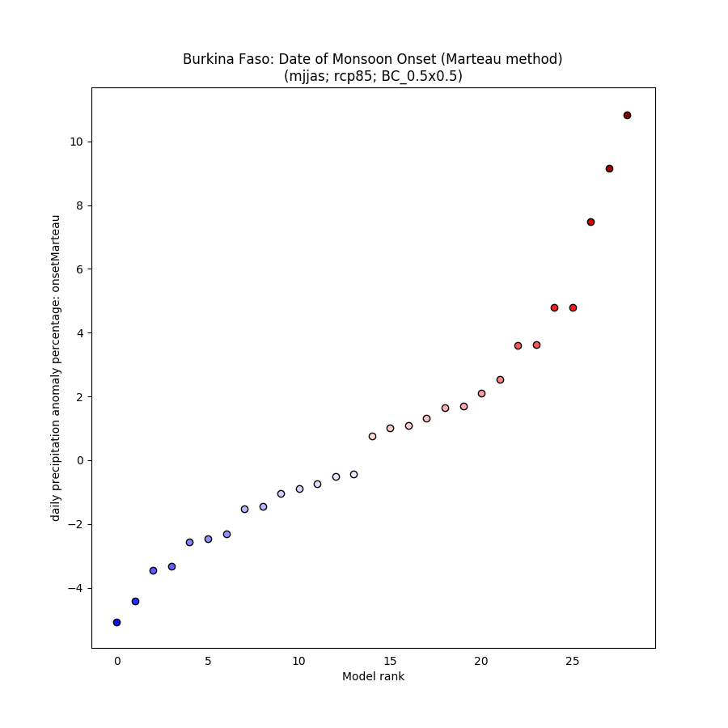

## Spaghetti timeseries

### All scenarios for 1950-2100

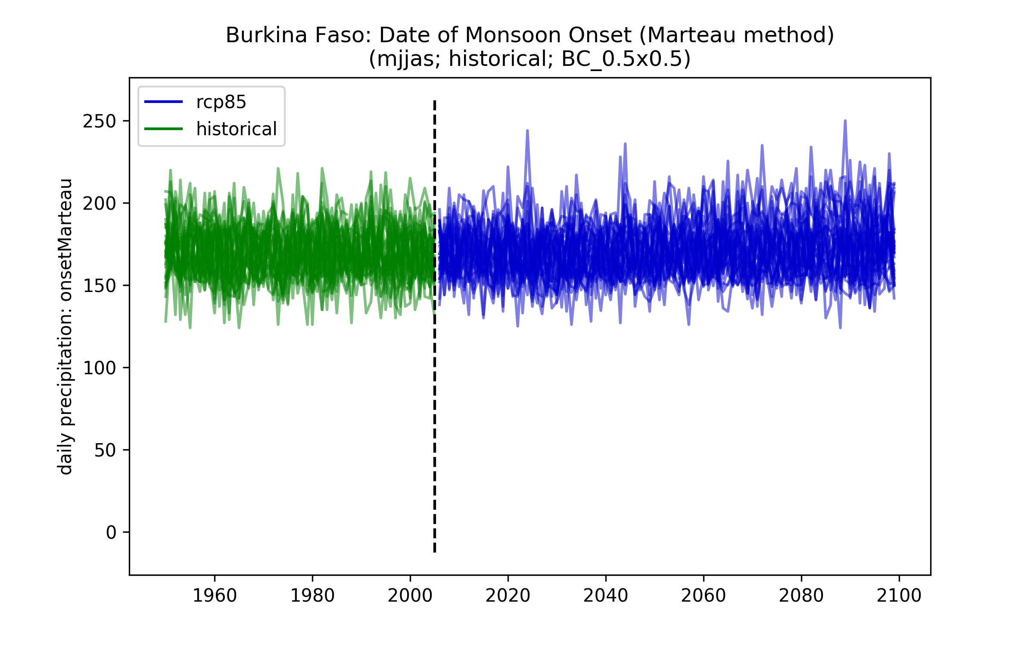

## Maps of ensemble spread (10th and 90th percentiles)

### Each scenario (and historical) individually

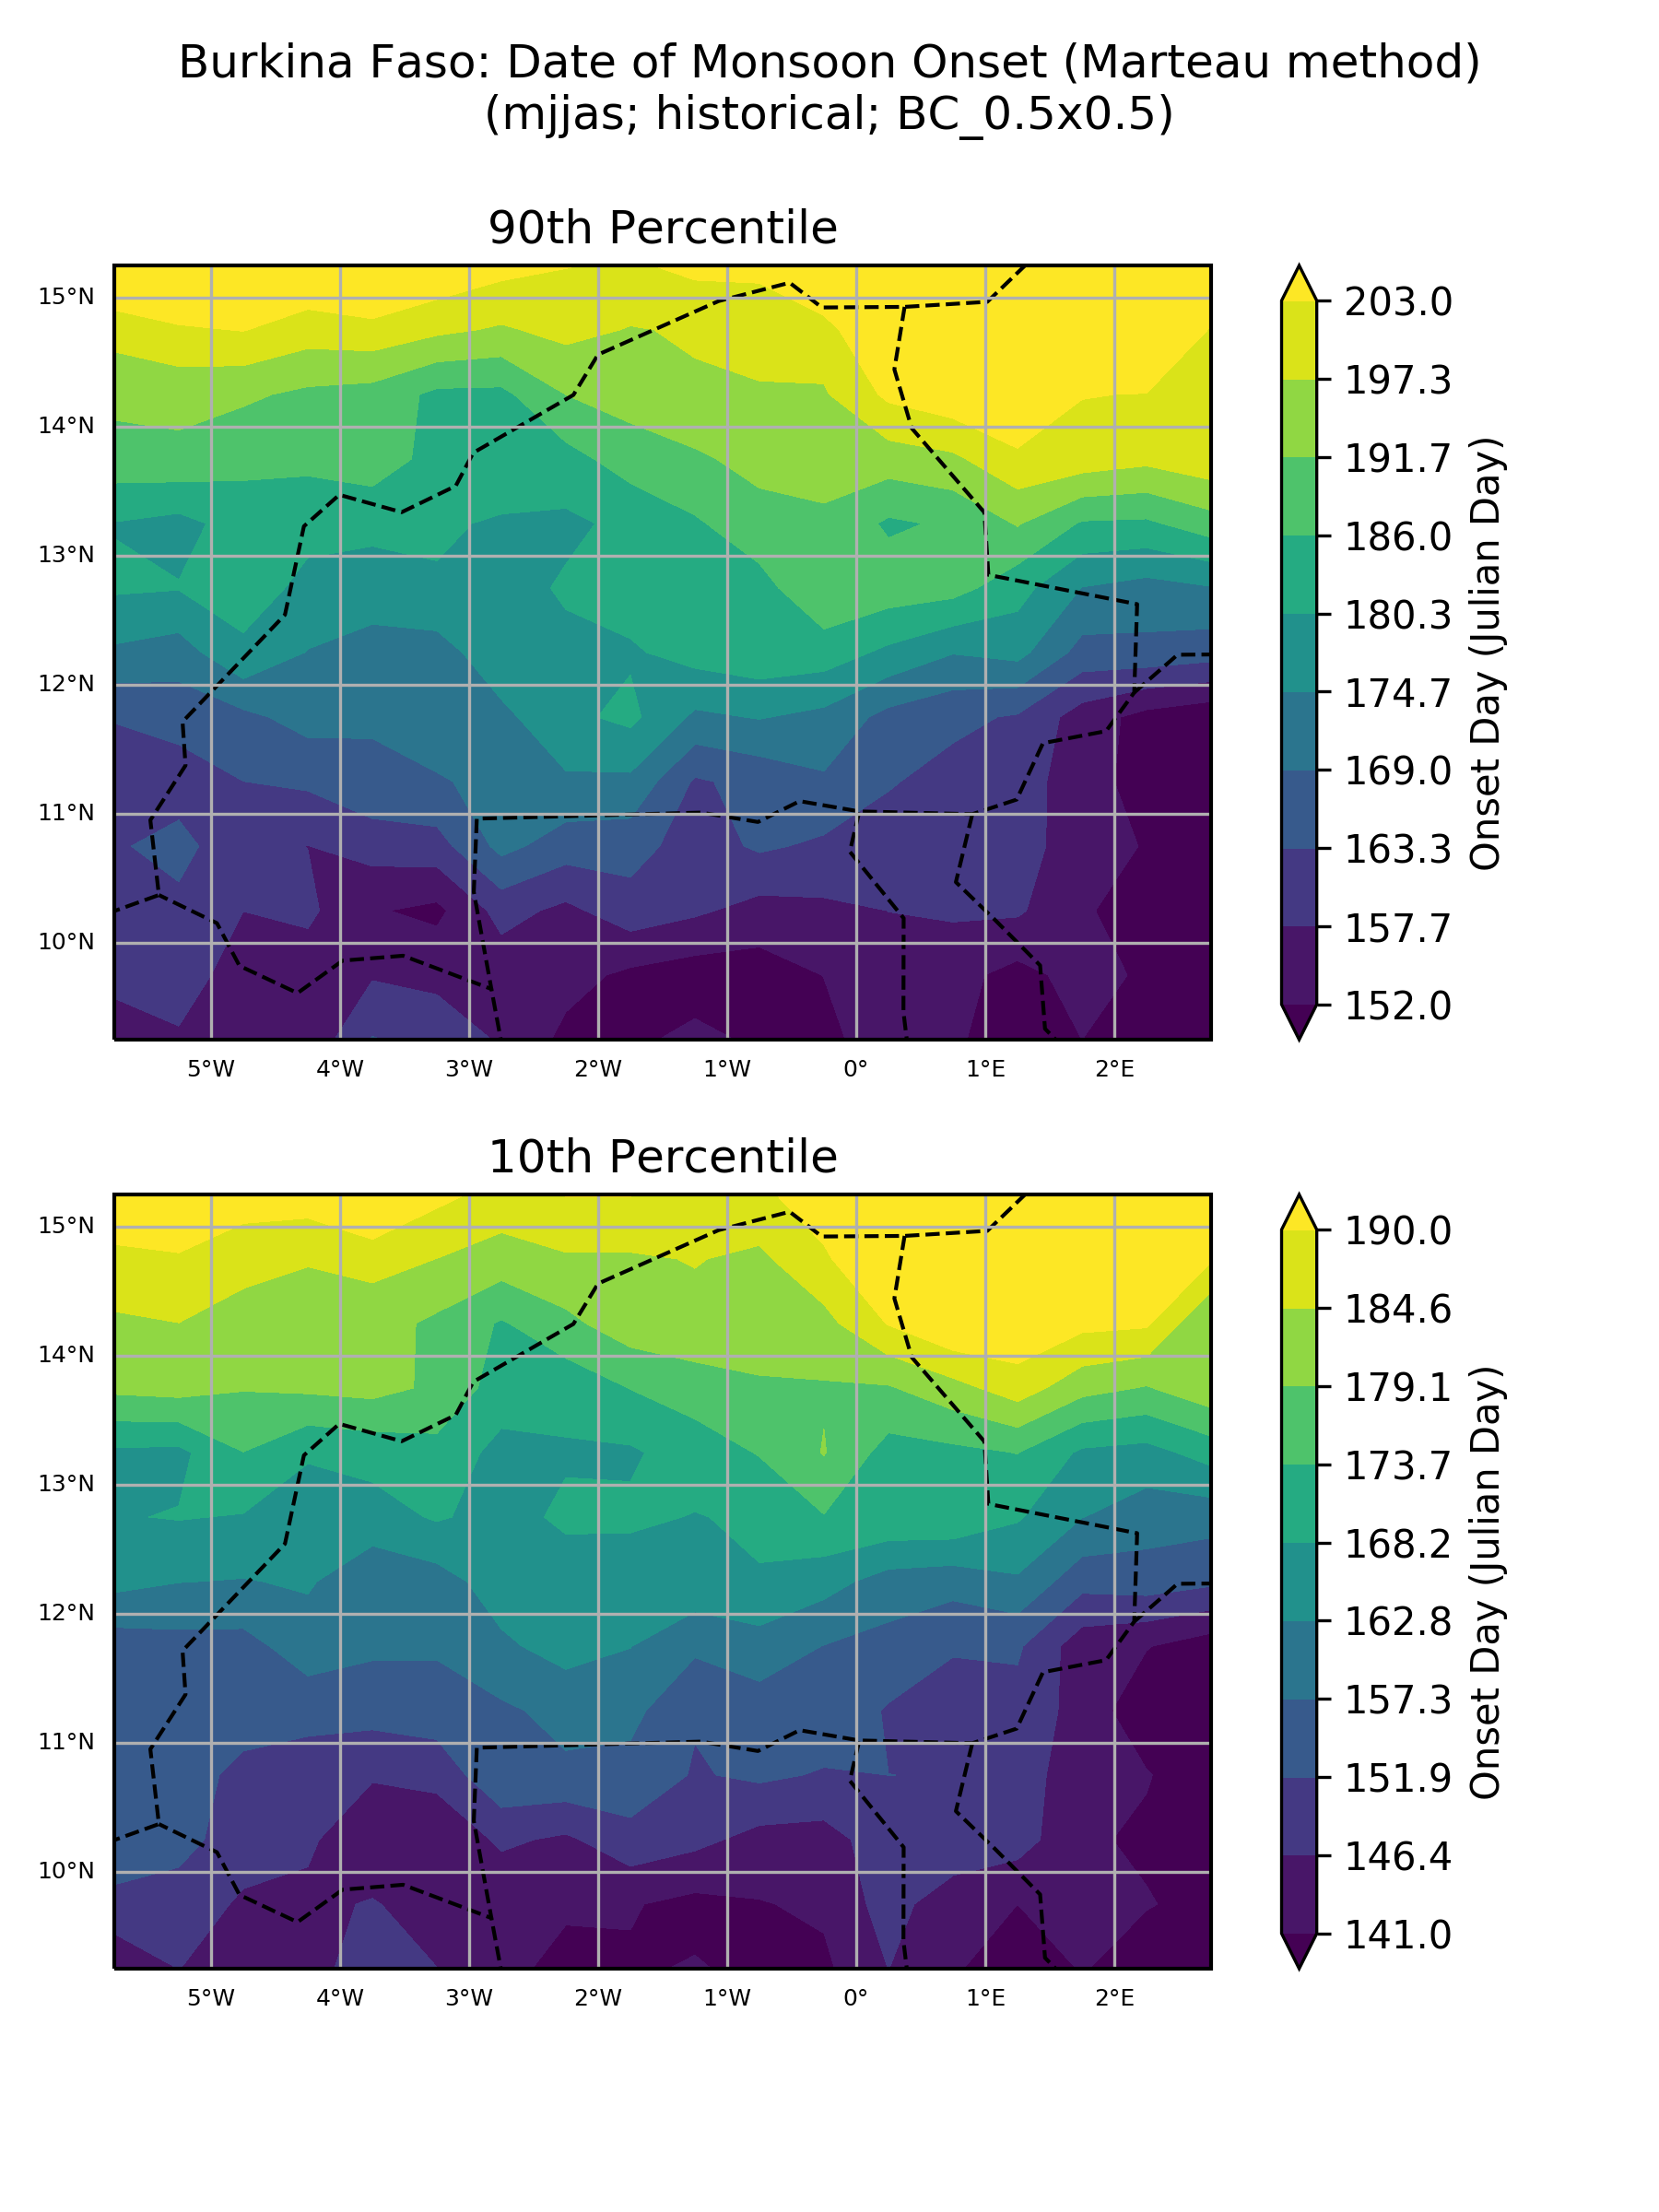

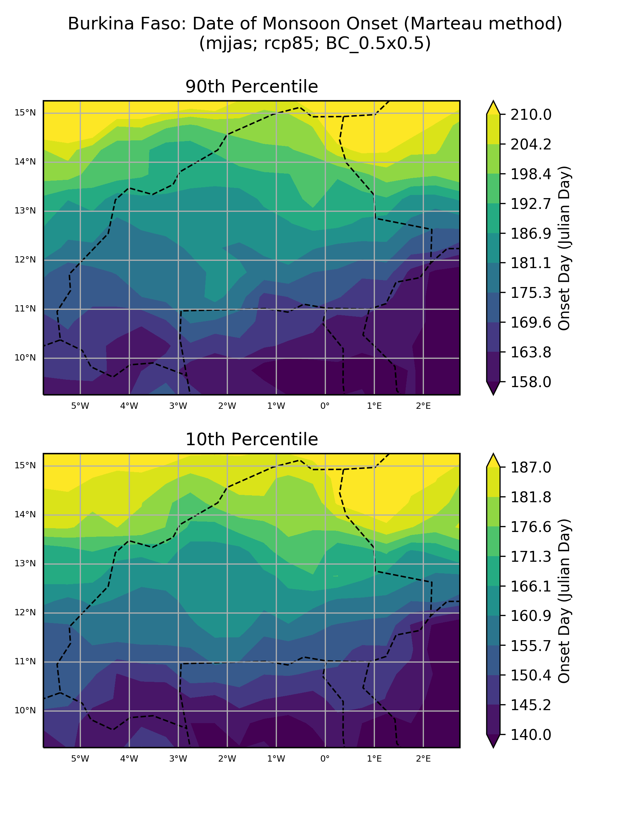

### Absolute anomaly (one scenario)

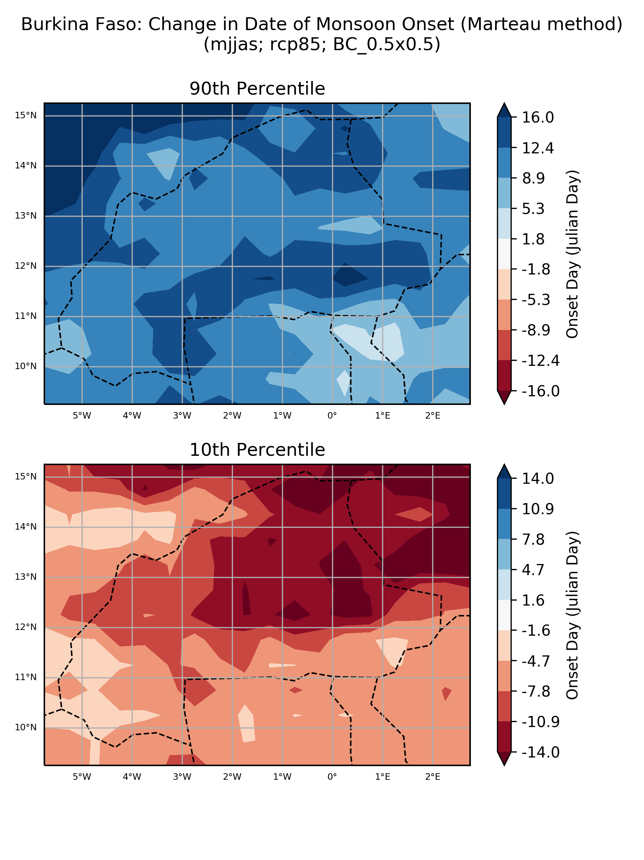

### % anomaly (one scenario)

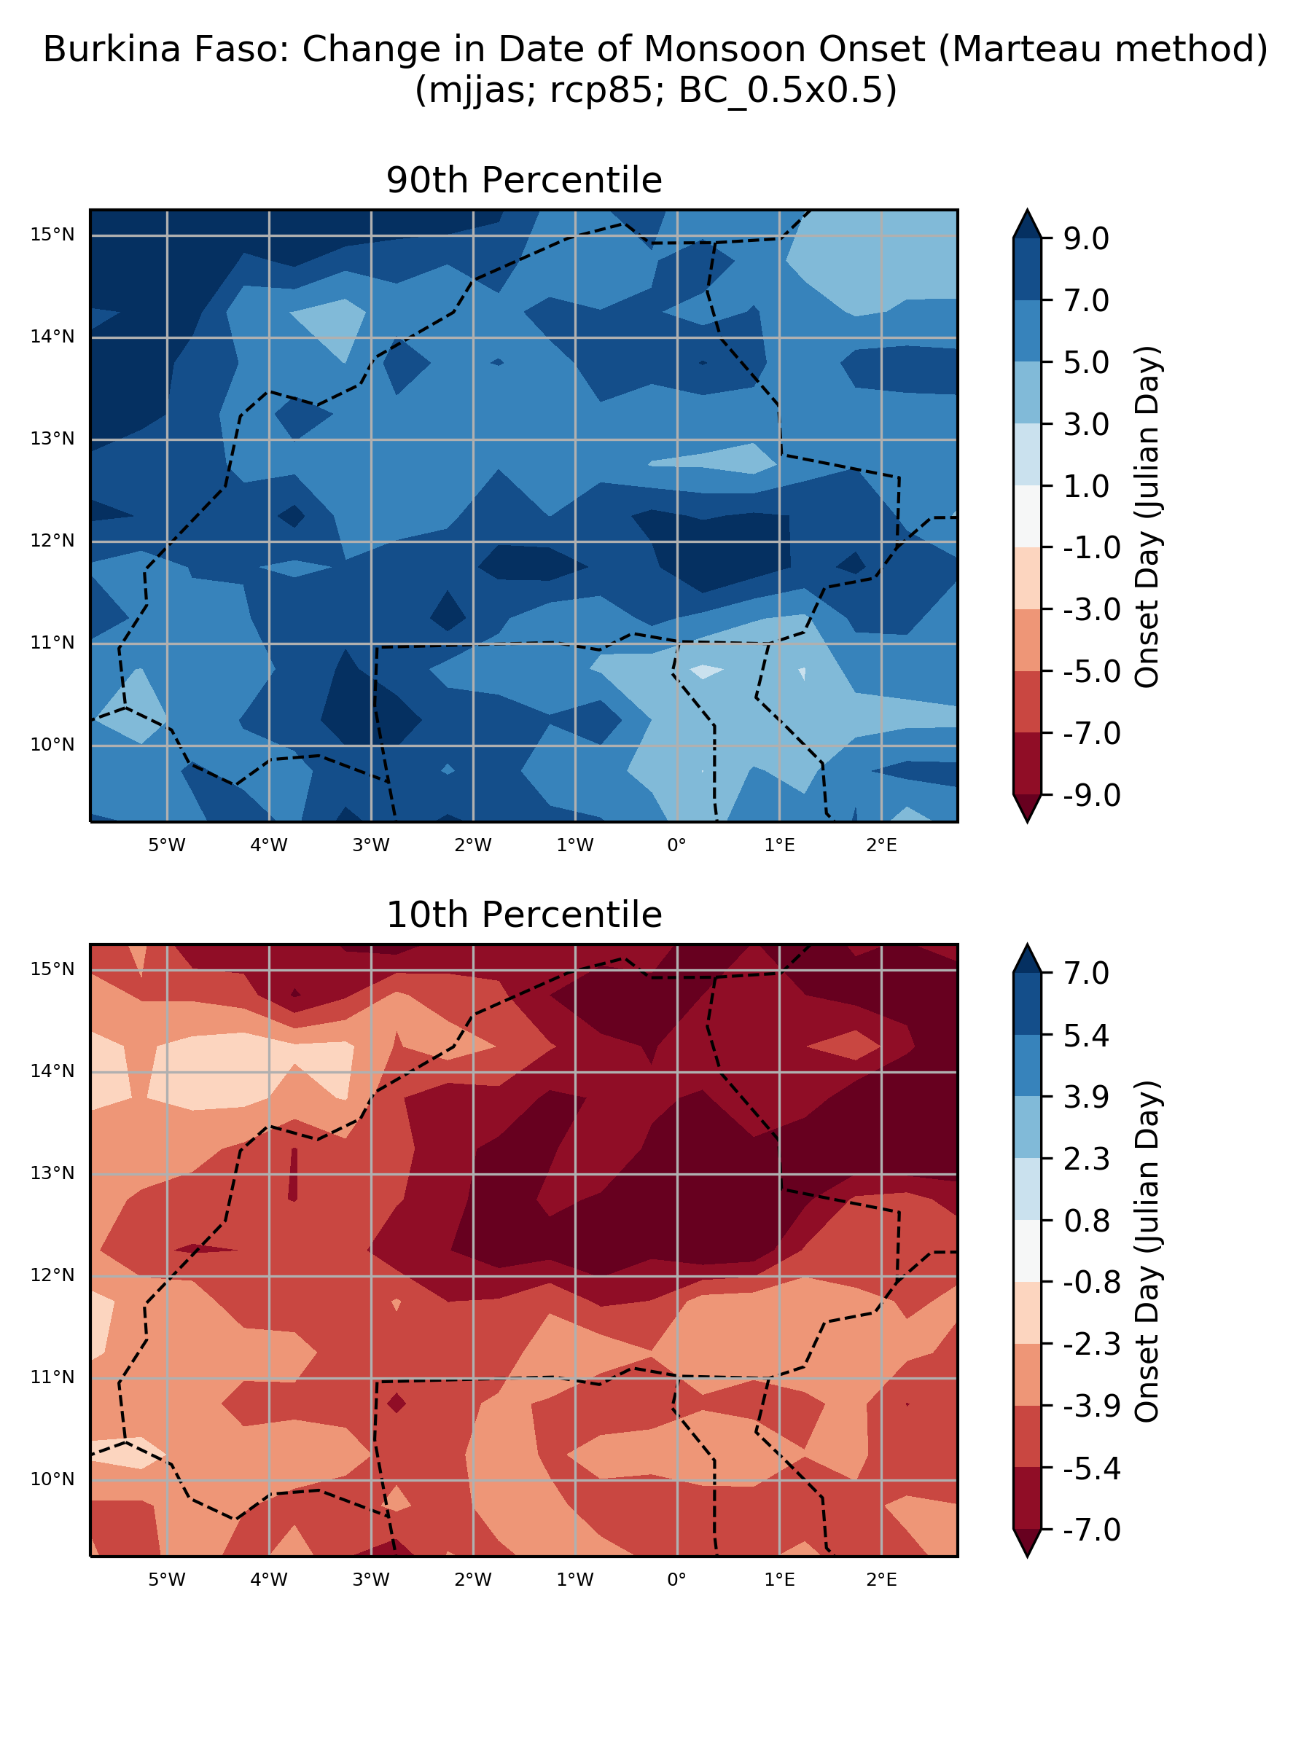

## ‘Number of model’ histograms

### Absolute anomaly (one scenario)

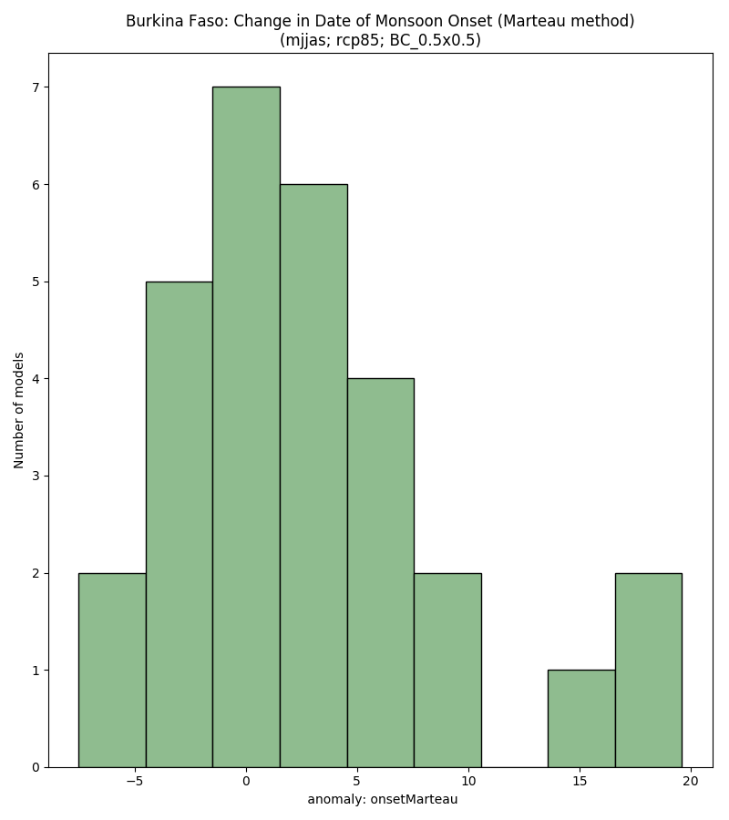

### % anomaly (one scenario)

